Homework assignments topics:

Computational analysis; ﻿detection of bias in directed speech; classification of different types of bias or hate speech; generation of paraphrases that anonymize or obfuscate demographic properties of a writer.

﻿Part 1: Foundations

● What is ethics

Ethics is a practical discipline. it is a study of ﻿what are good and bad ends to pursue

in life and what it is right and wrong to do in the conduct of life.

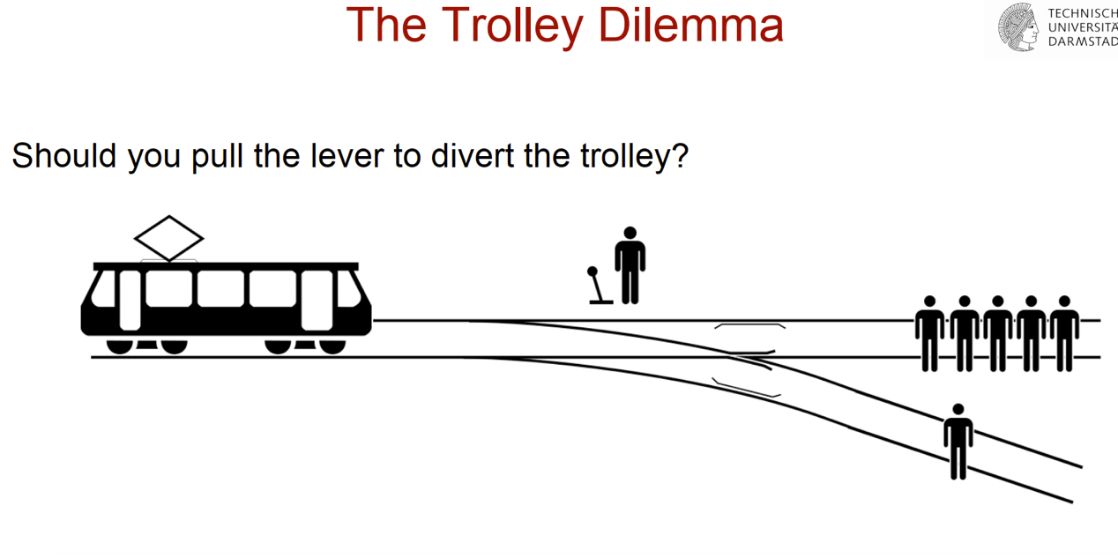

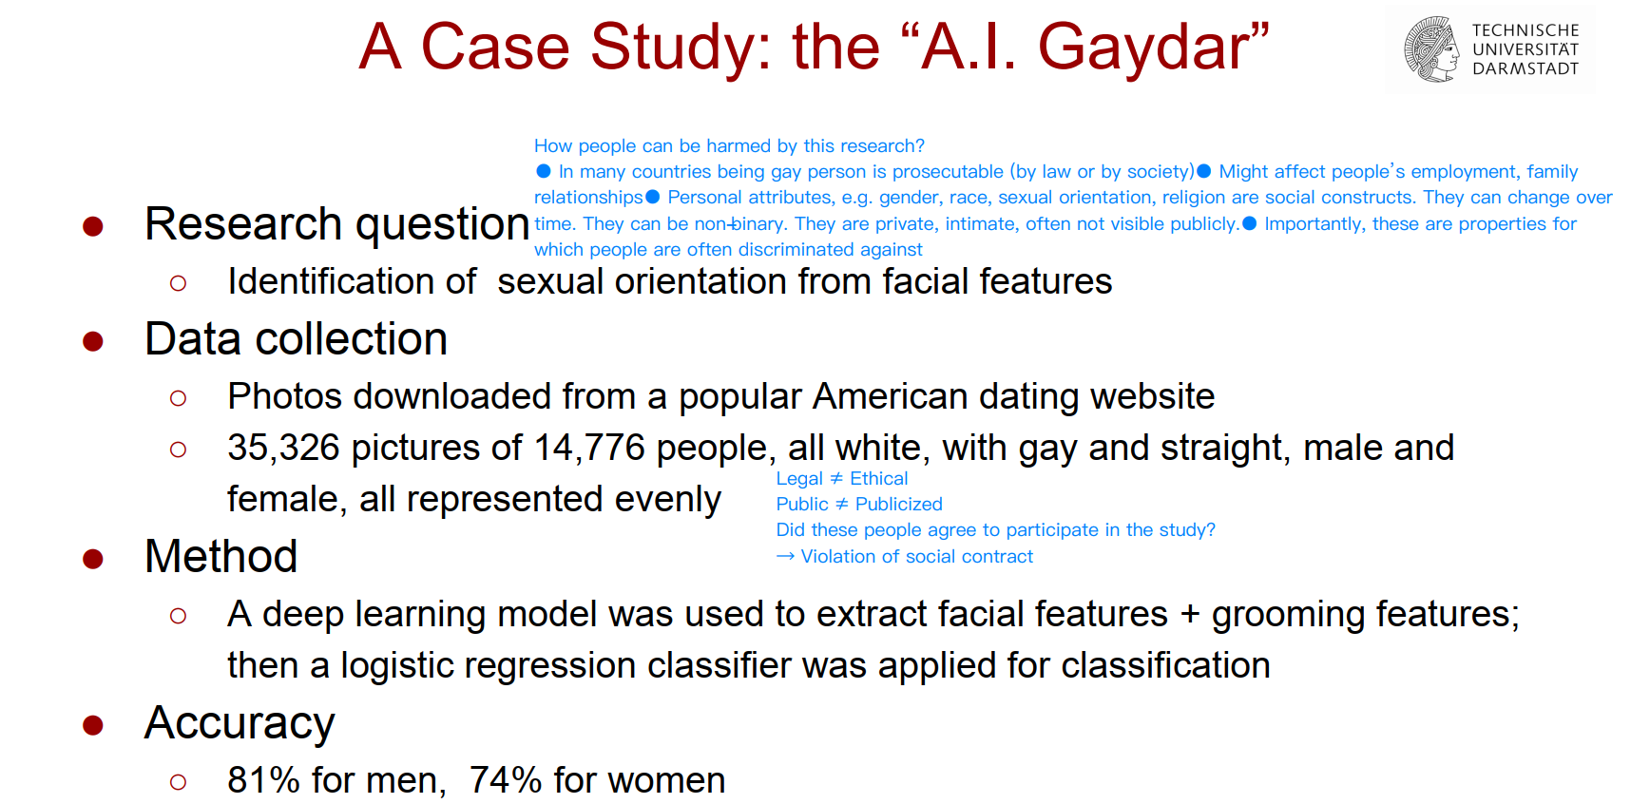

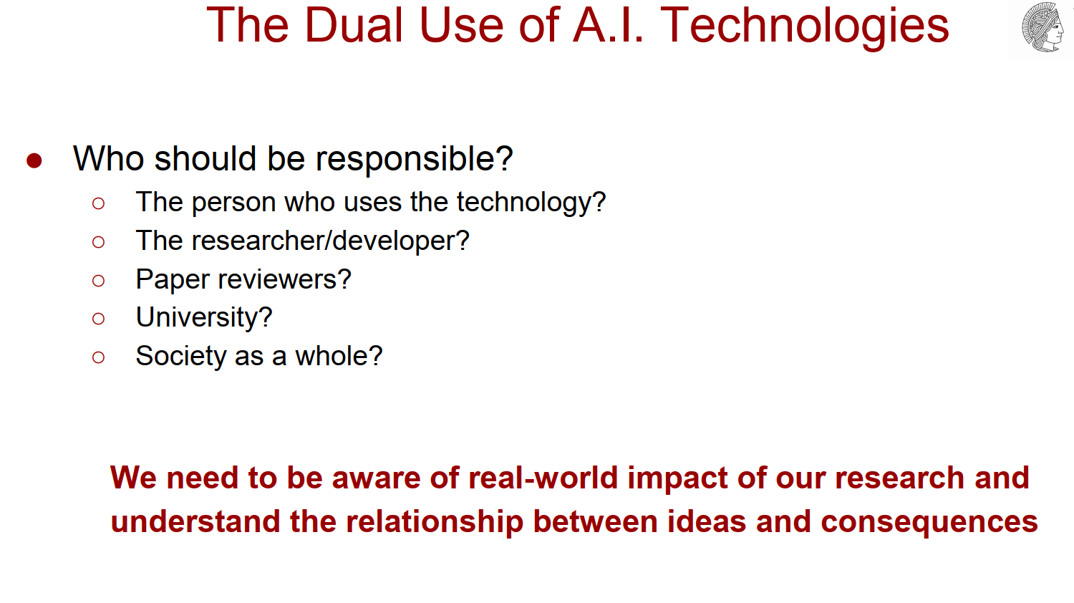

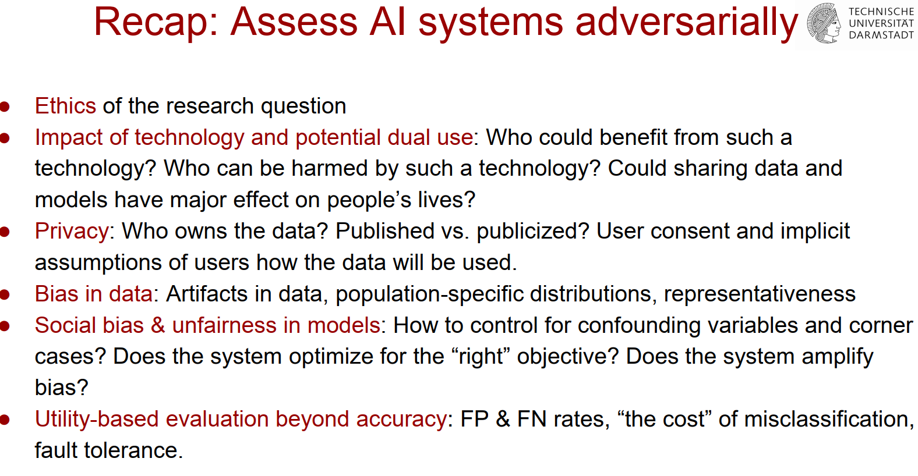

Ethics：的两种定义方法：

Deontology: ethics where the criteria for right and wrong are not in the consequences of an action, but the rules that it follows。从义务角度讲，义务论：伦理学的是非标准不在于行动的后果，而在于它所遵循的规则。也就是follow the rules, do your duty.

Consequentialism: ethics where the criteria for right and wrong are only in the consequences of an action。后果论：伦理学中的对错标准只在行动的后果中。

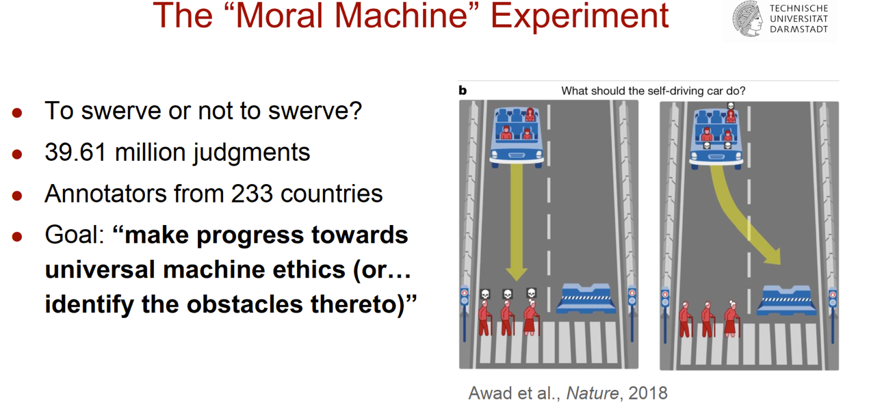

囚徒困境：如果一个人坦白（confess），他被释放另一个获刑3年，如果两个人都坦白，各获刑2年，如果两个人都不说，各获刑1年。

● Medical and psychological experiments

人体实验的10个ethical principles:

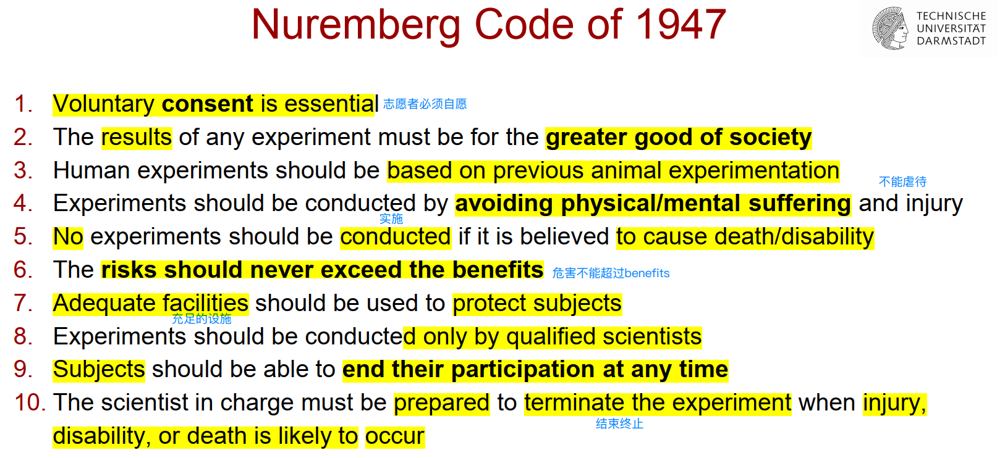

﻿ Tuskegee syphilis experiment

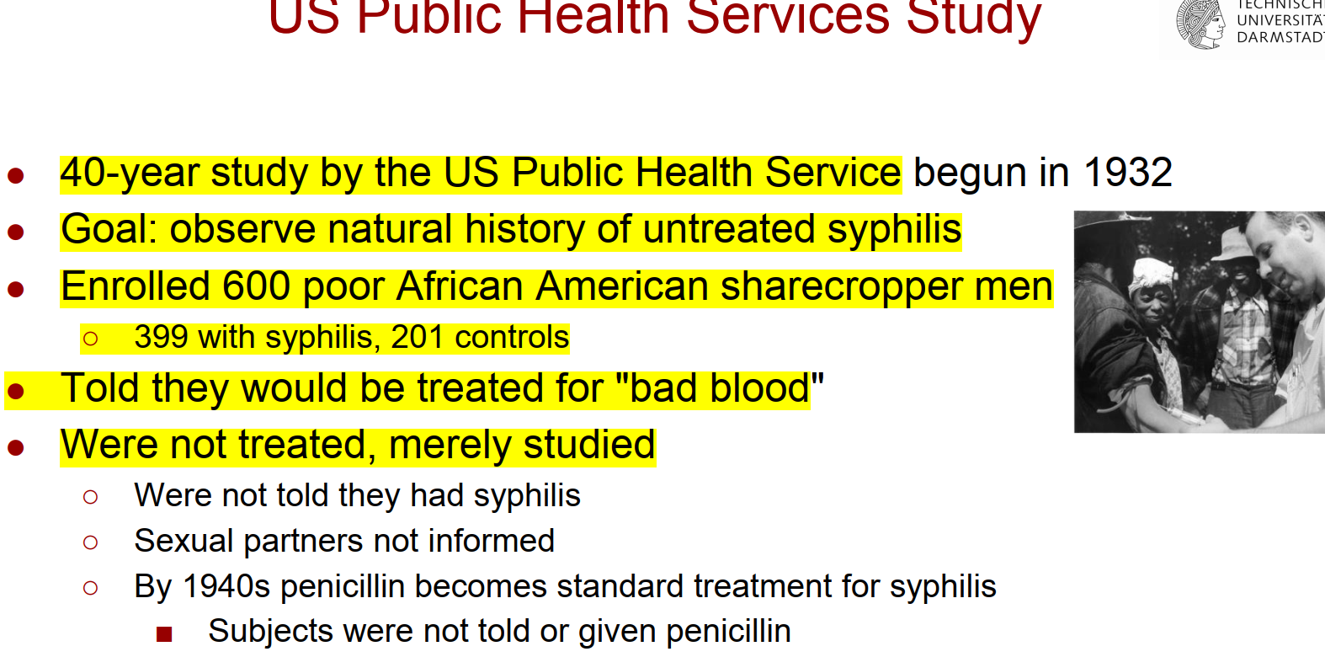

● Stanford prison experiment

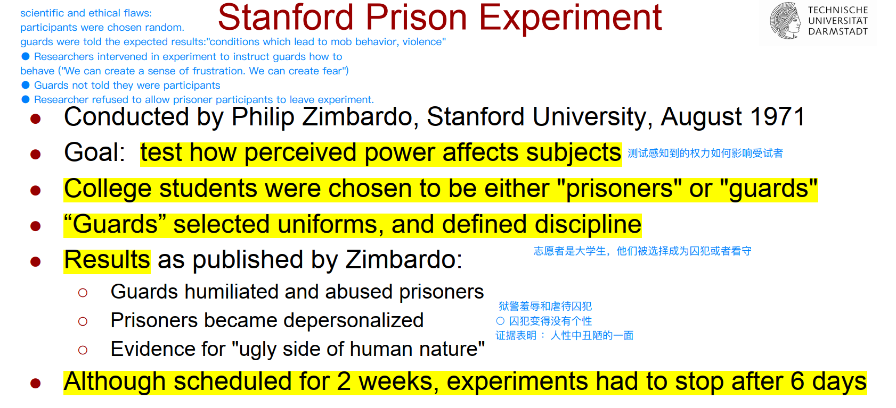

● Milgram experiment

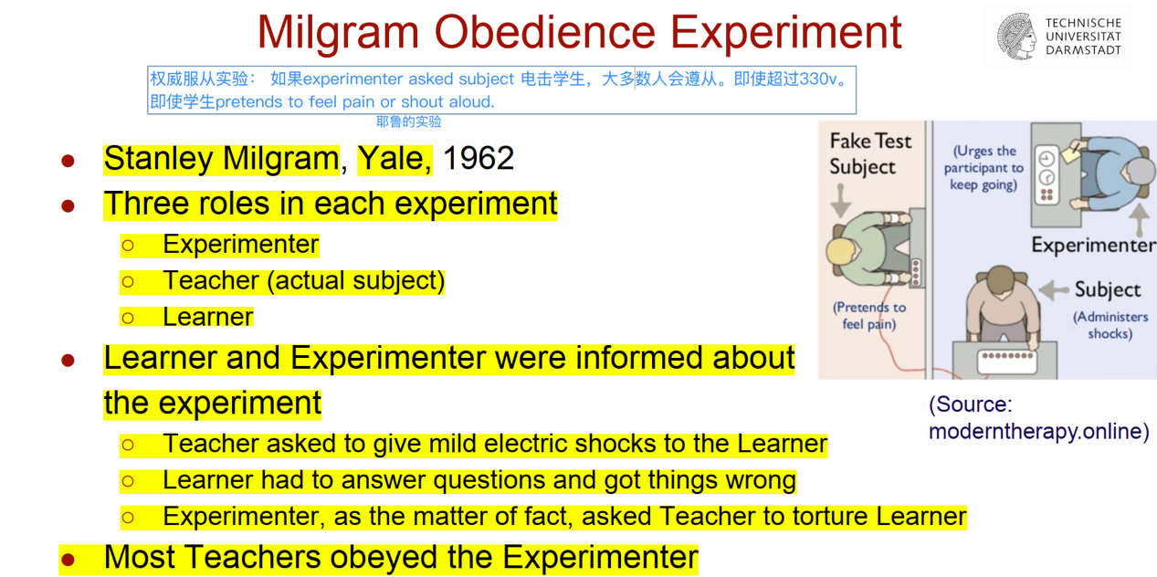

● National Research Act of 1974

这些实验特别是（Tuskegee实验）﻿led to the creation of the National Commission for the Protection of Human Subjects of Biomedical and Behavioral Research。

**﻿The Belmont Report：﻿Three basic ethical principles**

﻿1. Respect for Persons：Individuals should be treated as autonomous agents（ "Informed Consent" ）Persons with diminished autonomy are entitled to protection。1. 1.对人的尊重

个人应被视为自主的代理人○ "知情同意" 自主性减弱的人有权得到保护。

﻿2. Beneficence 2. 慈悲为怀

● Do no harm不造成伤害

● Maximize possible benefits and minimize possible harms. 将可能的利益最大化，将可能的伤害最小化。

﻿3. Justice公正

Who ought to receive the benefits of research and bear its burdens? 谁应该得到研究的好处并承担其负担？

● Fair procedures and outcomes in the selection of research subjects在选择研究对象时要有公平的程序和结果

● Advances should benefit all进展应惠及所有人

● IRB and human subjects：

**IRB：**

﻿● Reviews all human experimentation

﻿● Reviews all human experimentation ﻿：Medical School vs Engineering School

﻿● Board consists of (primarily) non-expert peers（﻿Also helps educate new researches and makes suggestions to find solutions to ethical issues）董事会由（主要）非专家同行组成。也帮助教育新的研究，并提出建议，以找到解决

伦理问题的解决方案

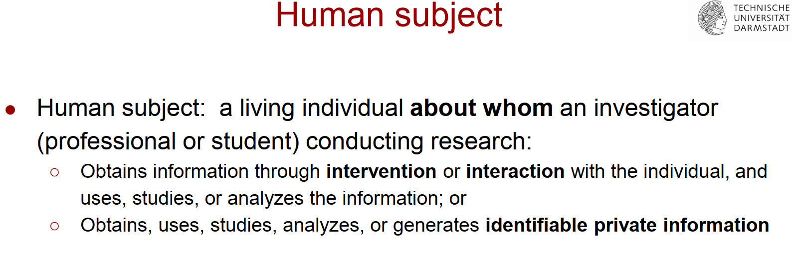

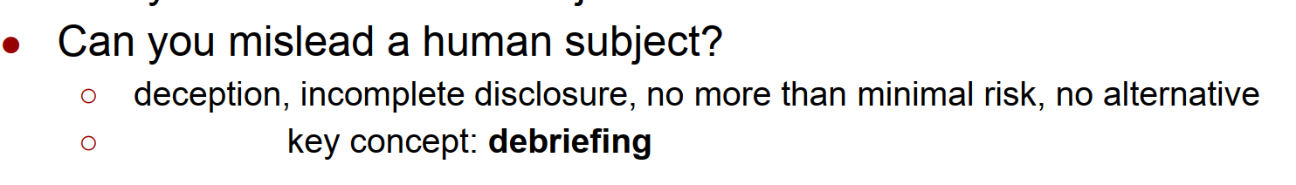

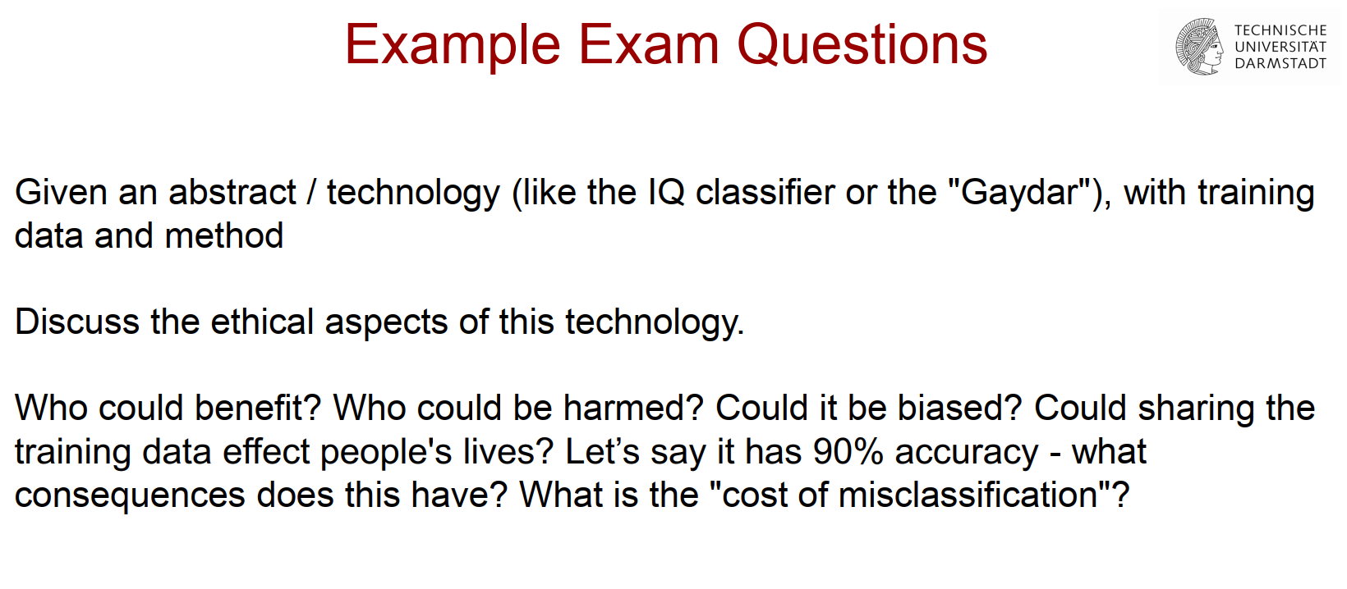

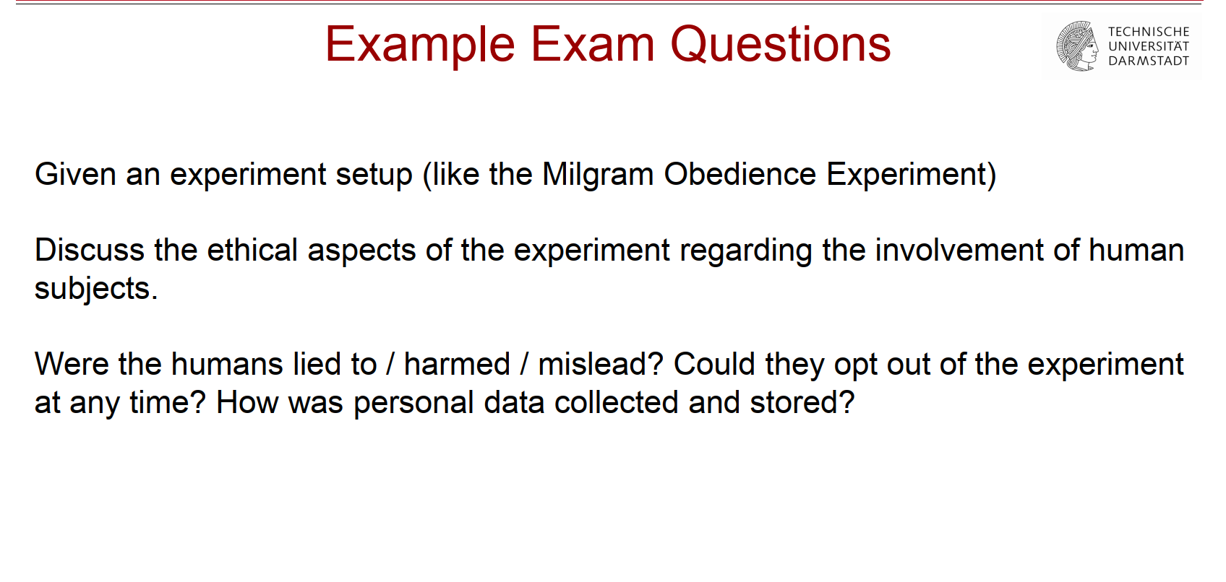

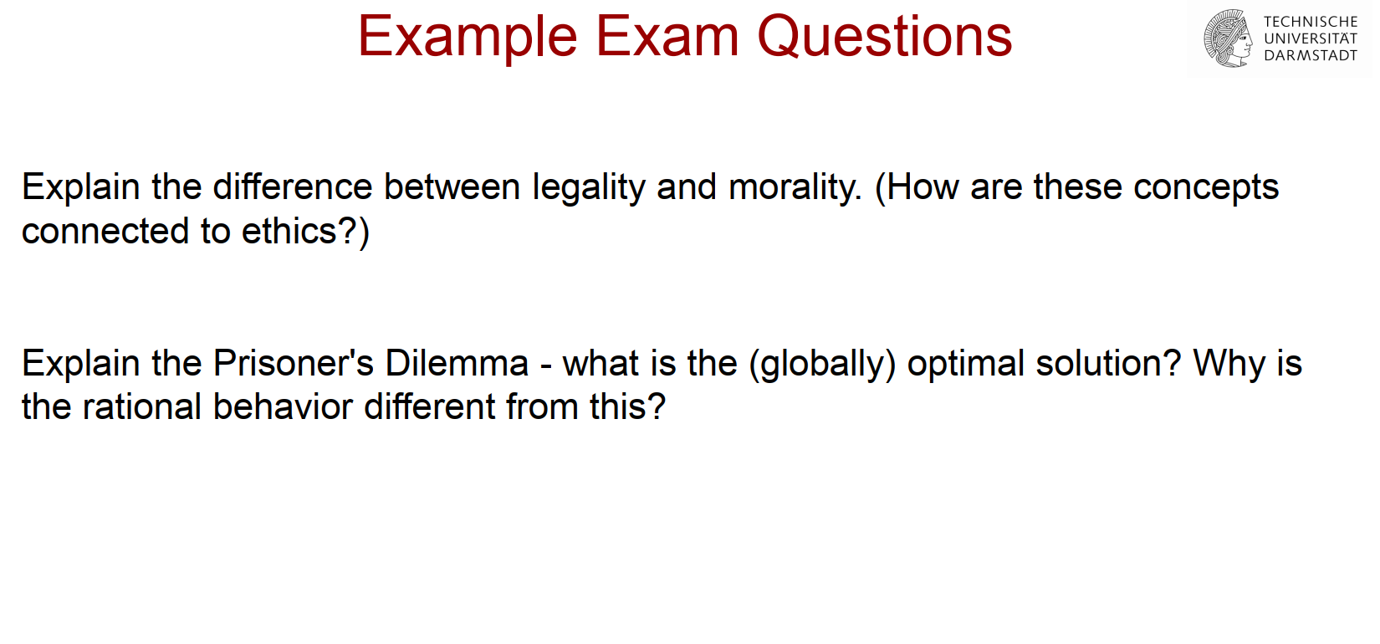

﻿Part 2: Misrepresentation and bias

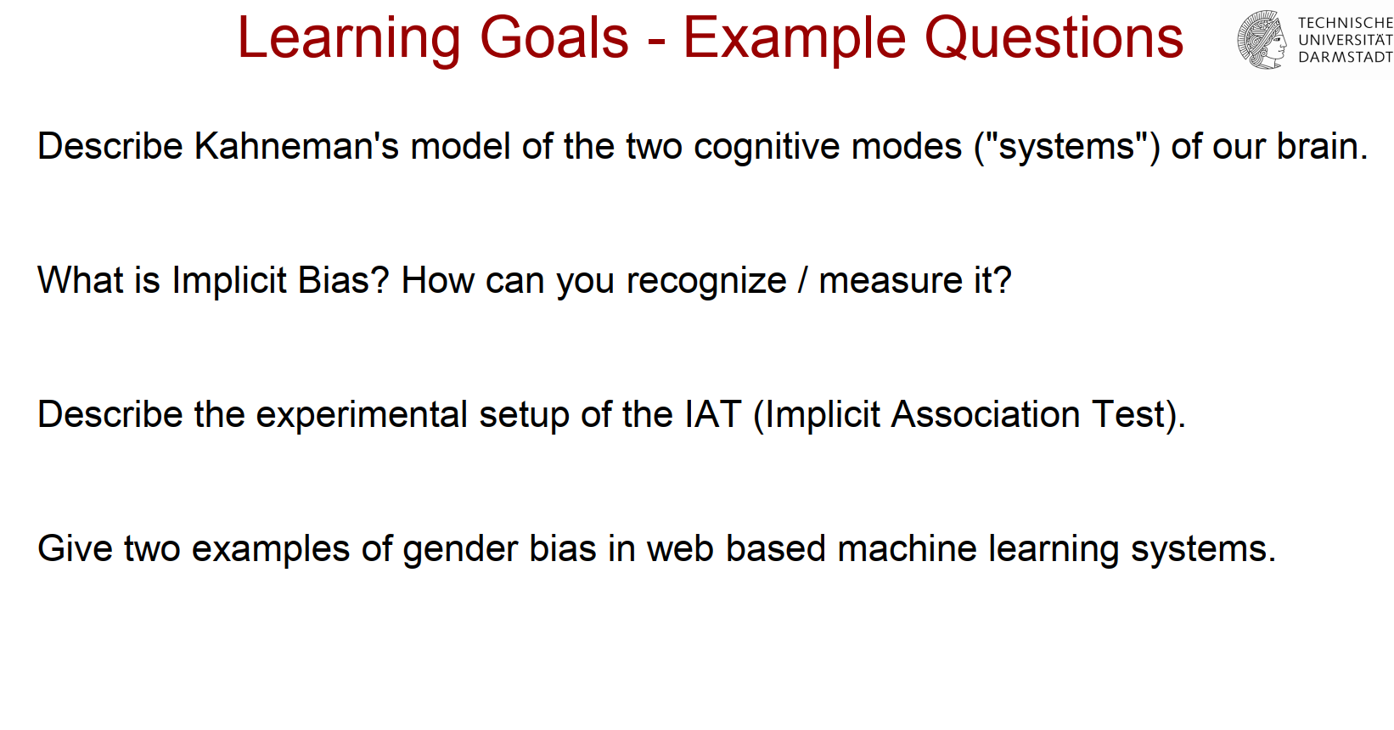

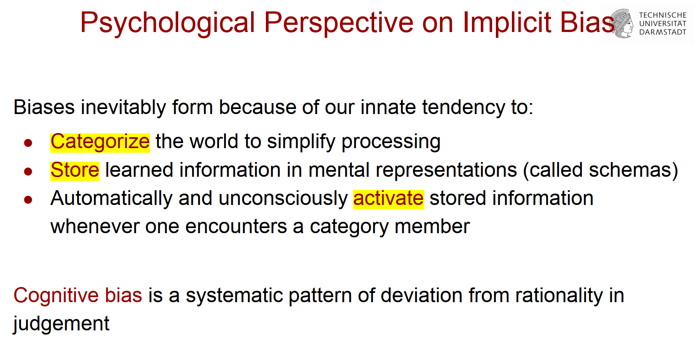

● Automatically and unconsciously activate stored information

whenever one encounters a category member

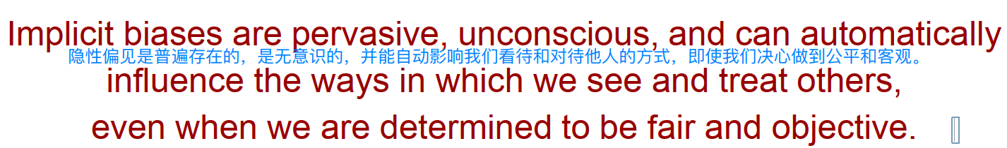

● Theoretical background, IAT（how to recognize implicit biases）

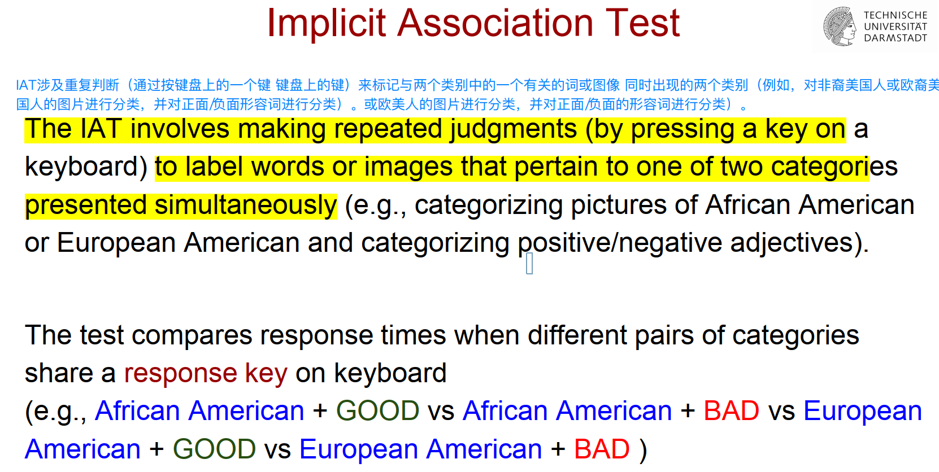

Implicit bias 是怎么展现的？

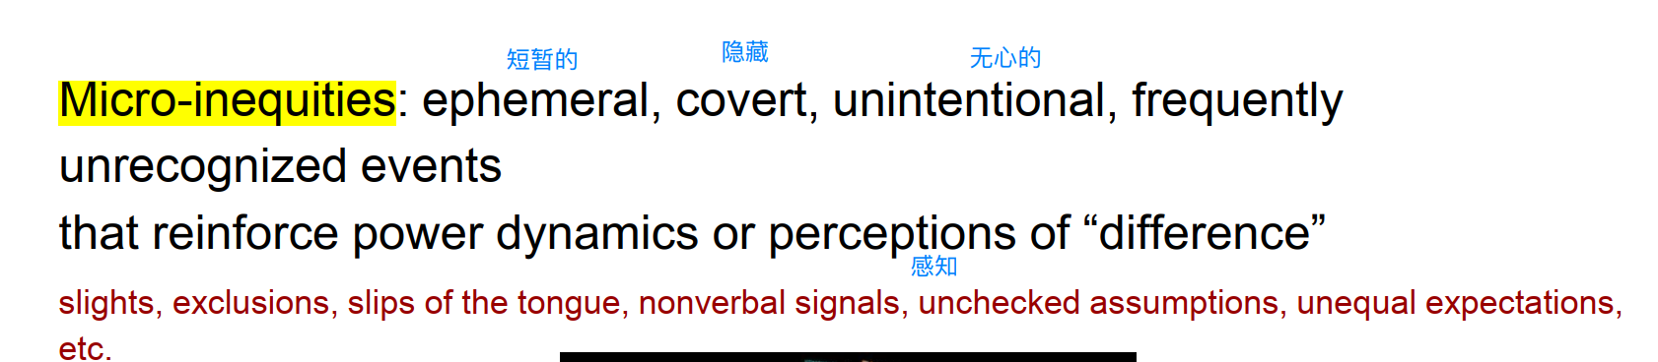

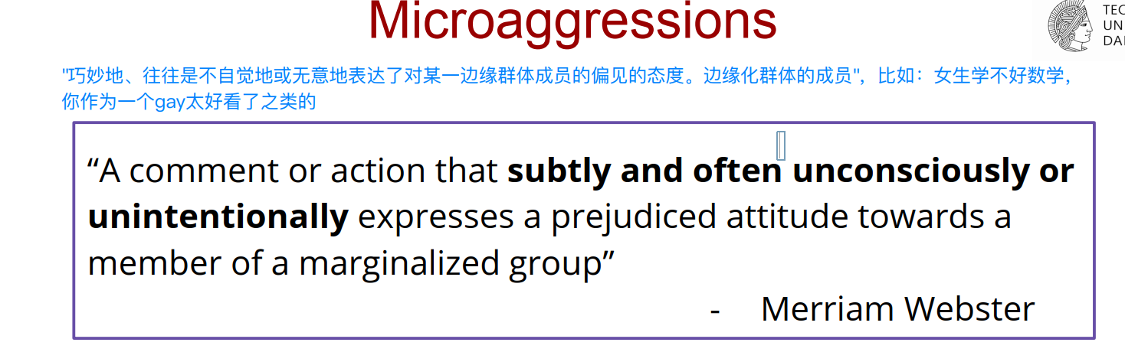

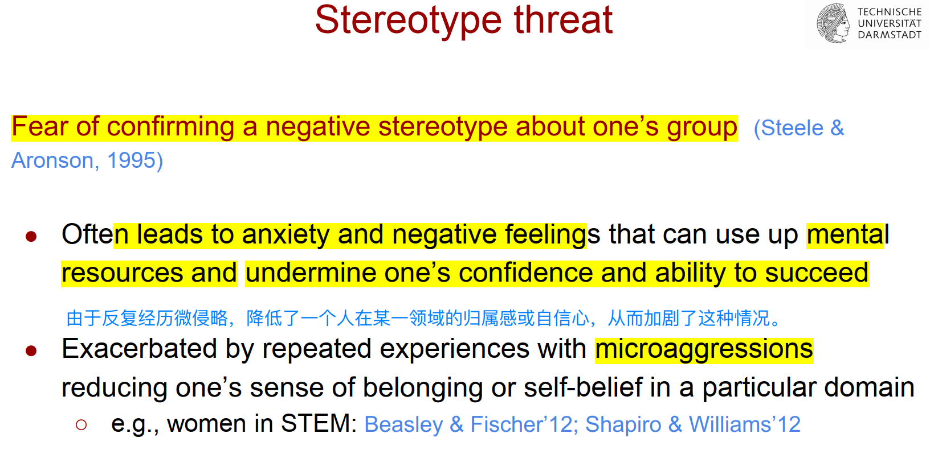

● Algorithms to identify bias in NLP models and data

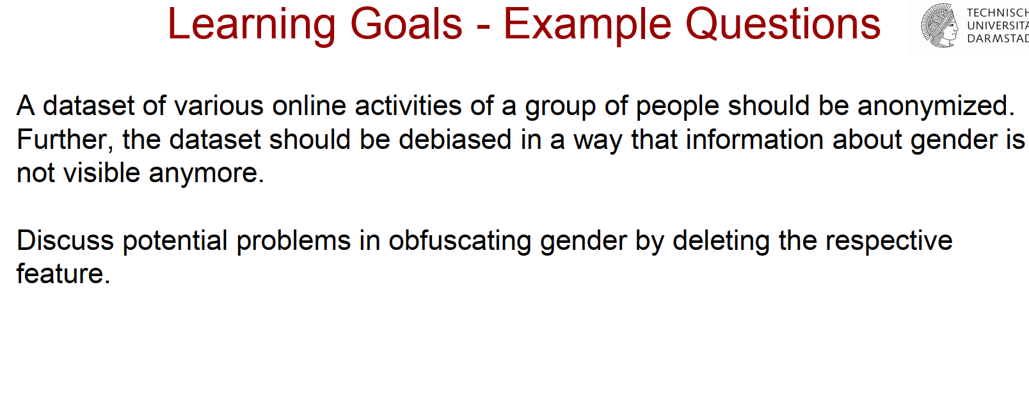

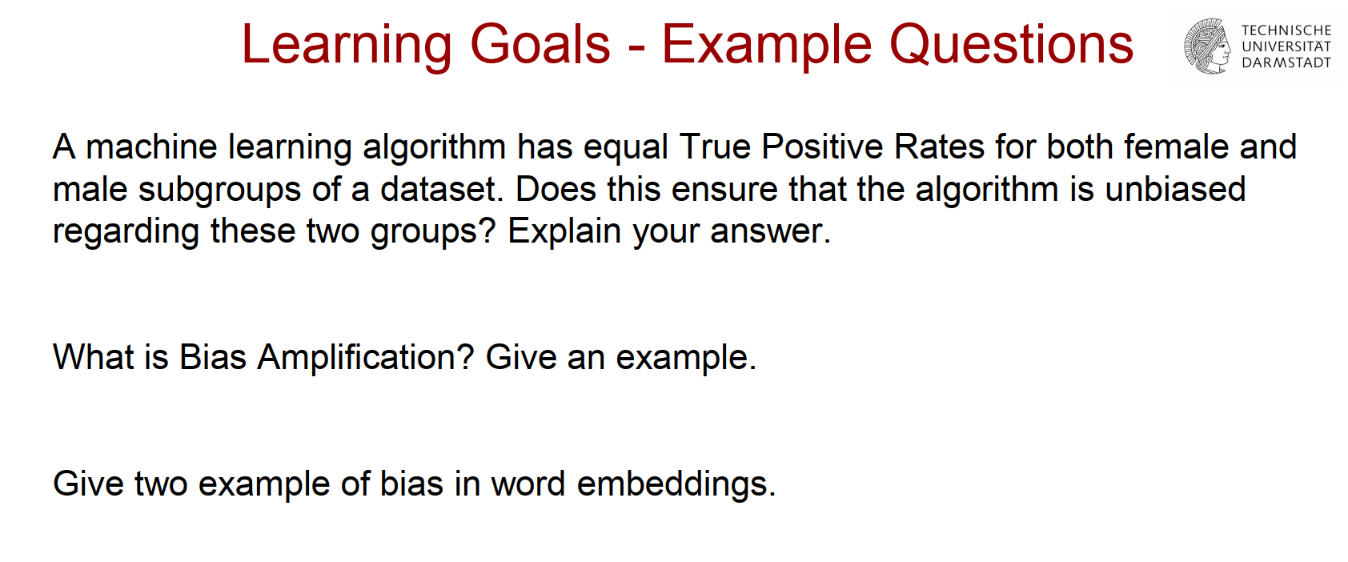

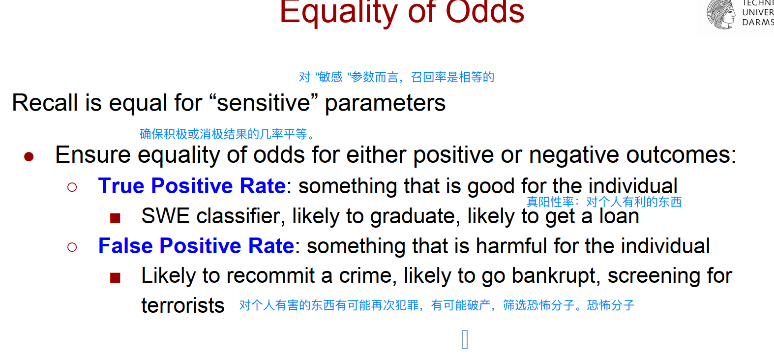

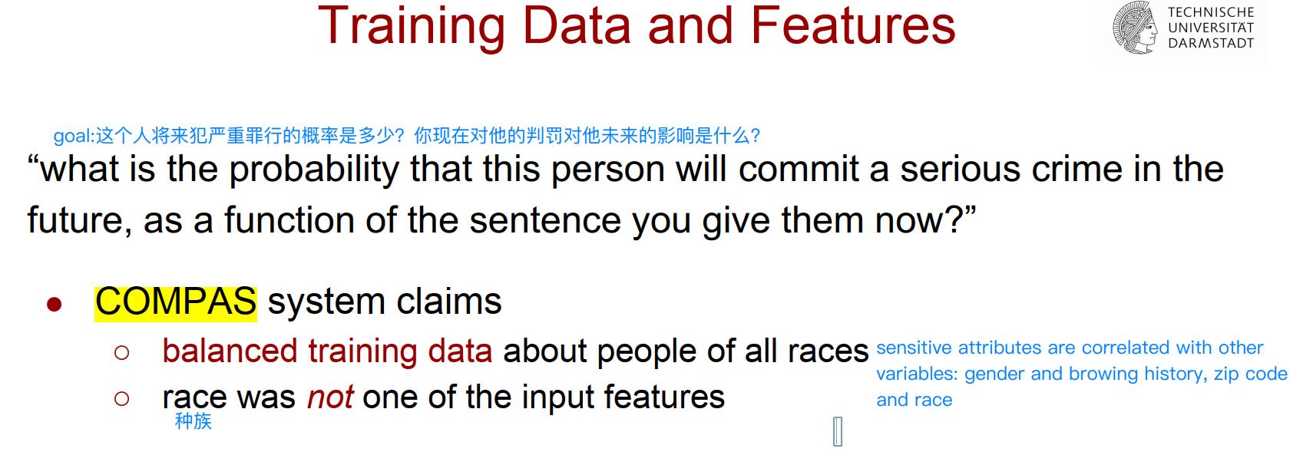

● Debiasing

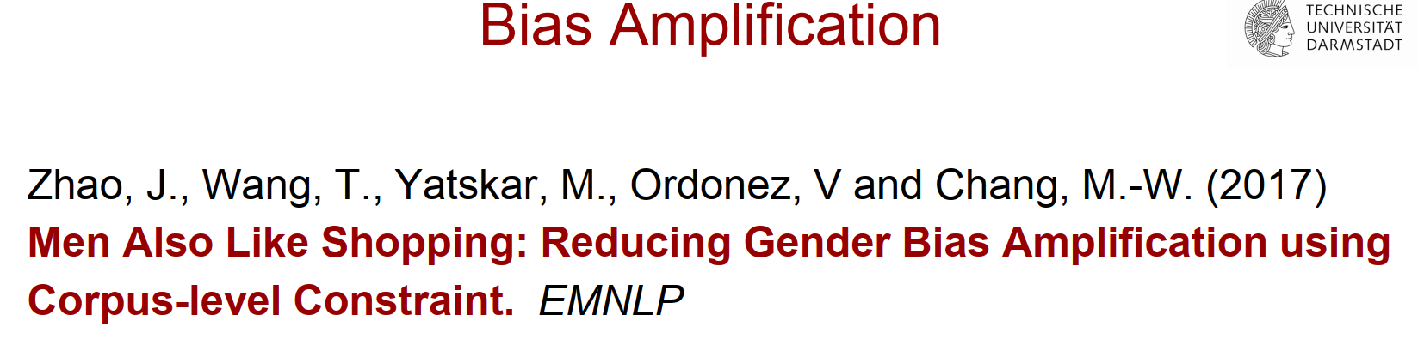

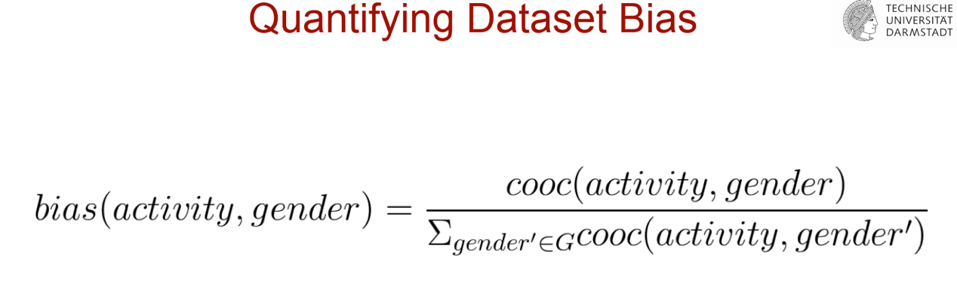

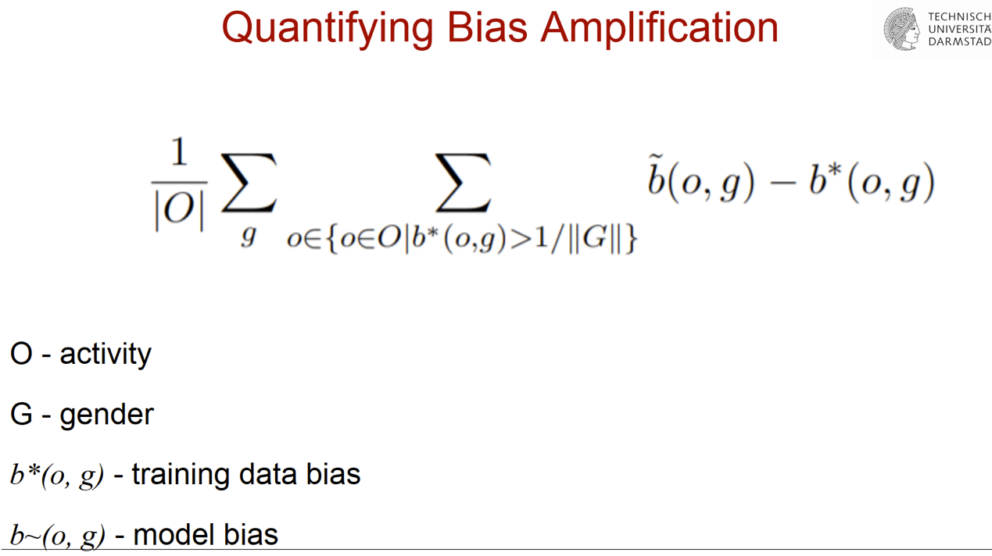

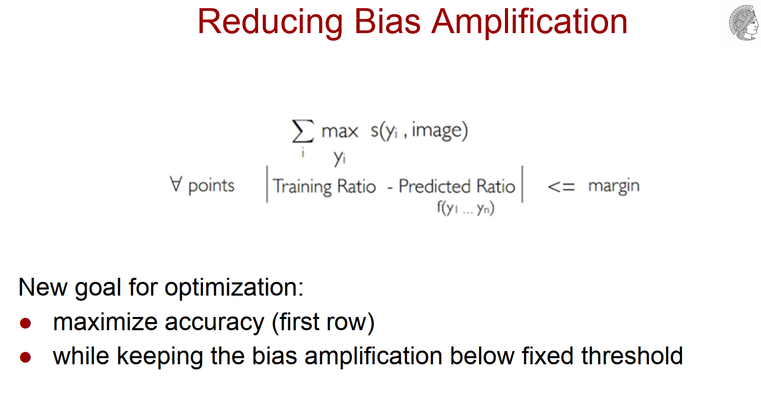

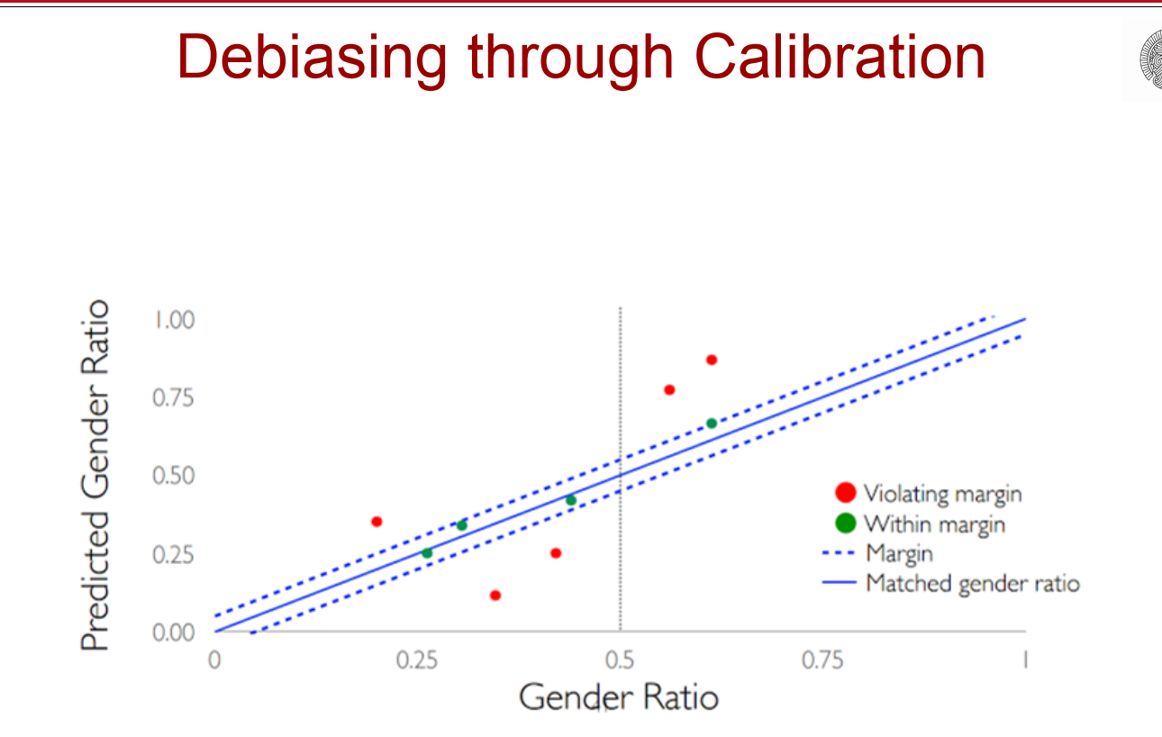

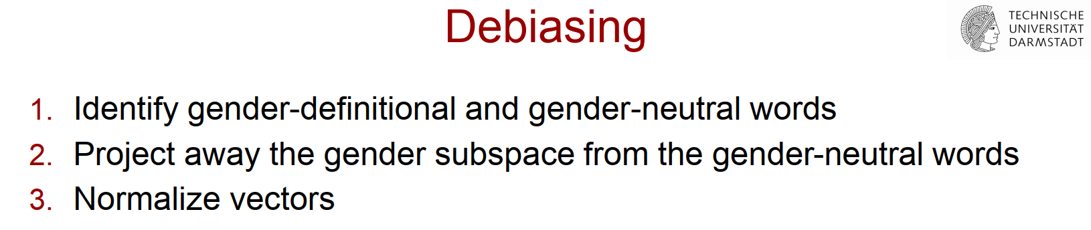

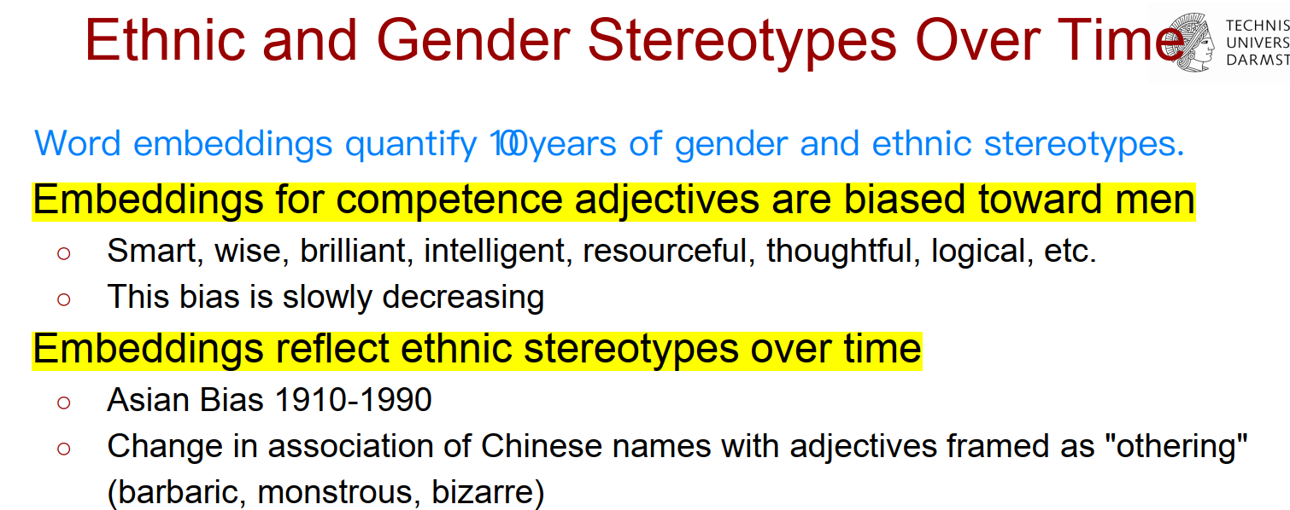

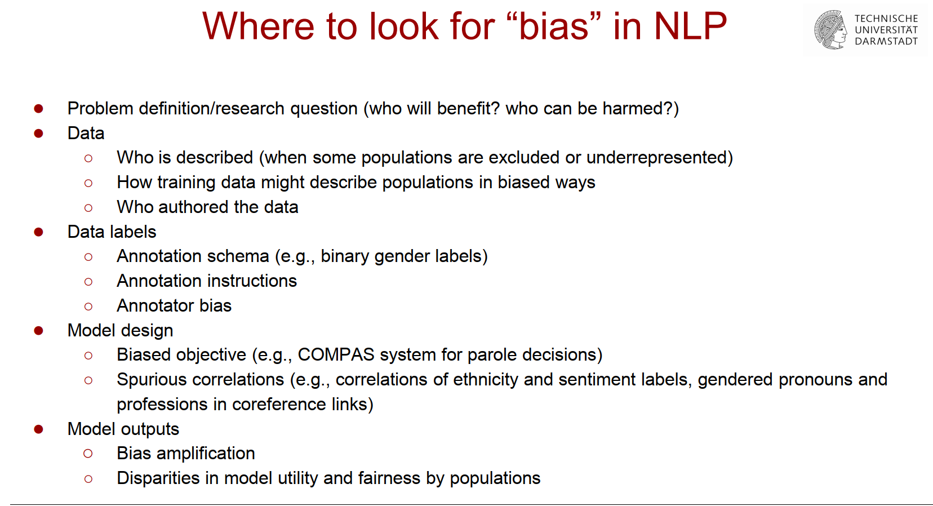

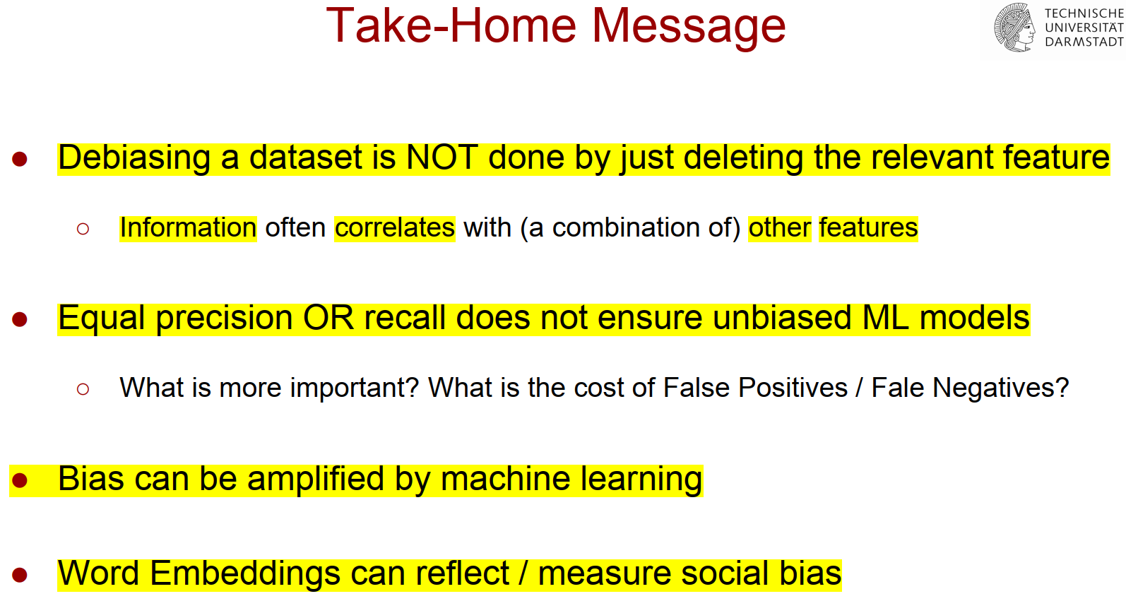

﻿Part 3: InCivility in communication

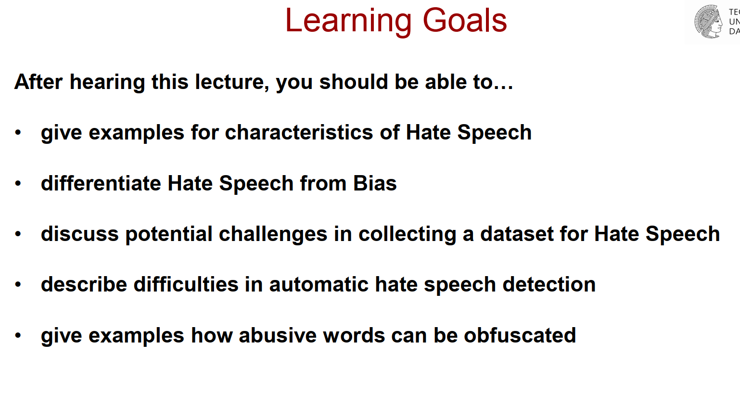

**What is hate speech?**

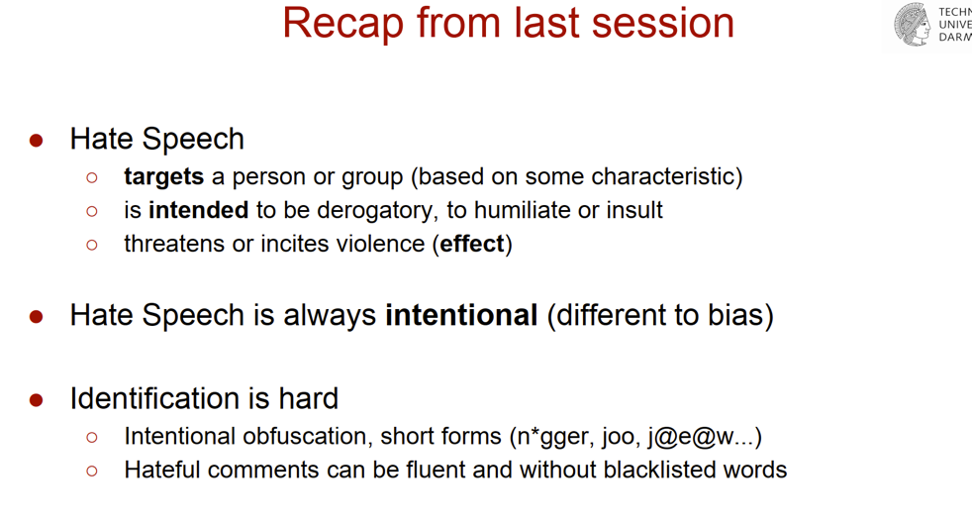

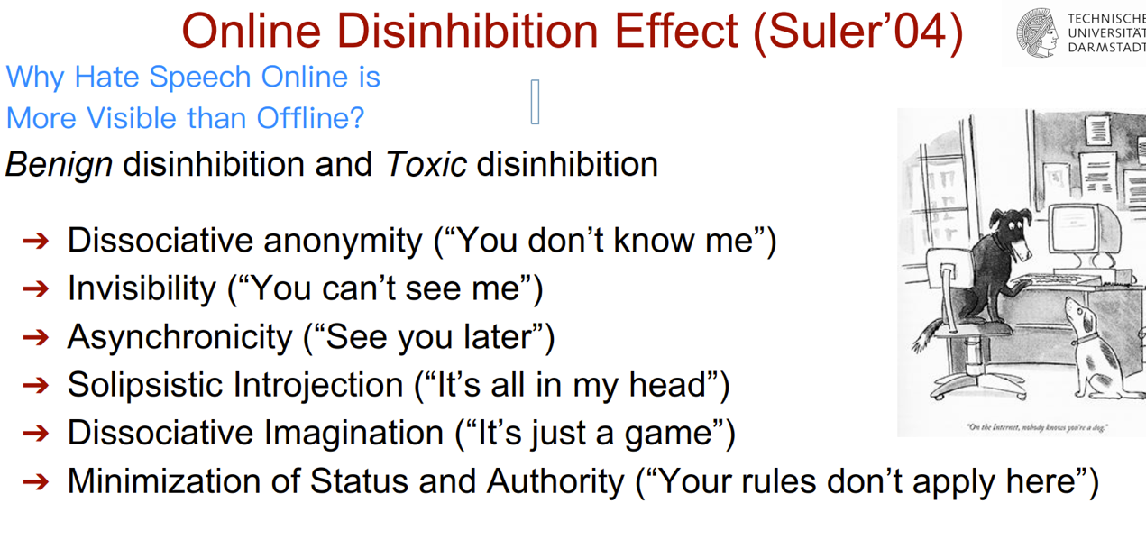

**Hate speech identification is hard.:**

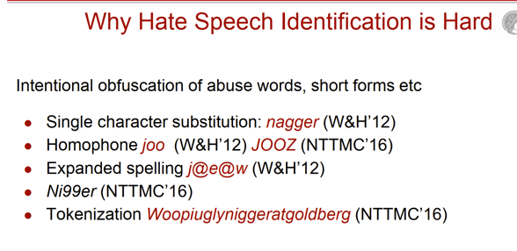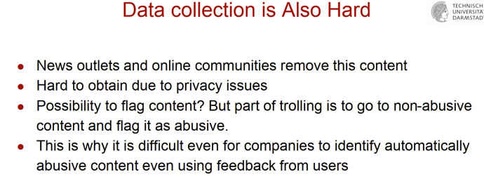

所以说发现hate speech是一件很难的事情。

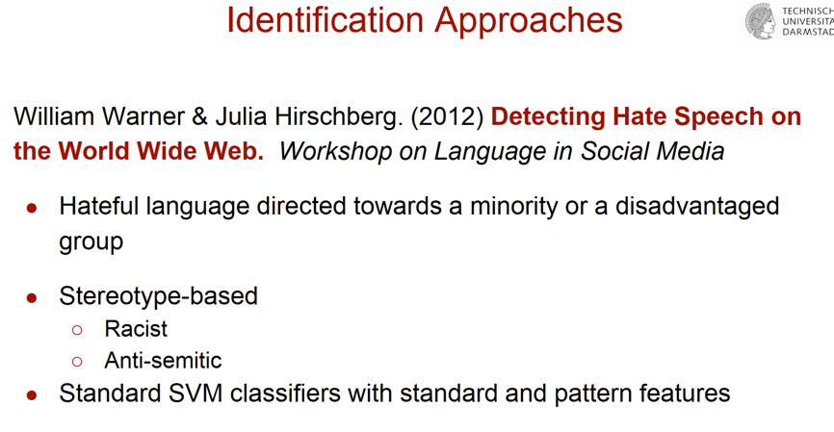

● Techniques to monitor trolling, hate speech, abusive language,

cyberbullying, toxic comments

● Hate speech and bias in conversational agents

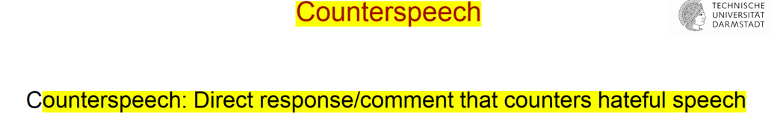

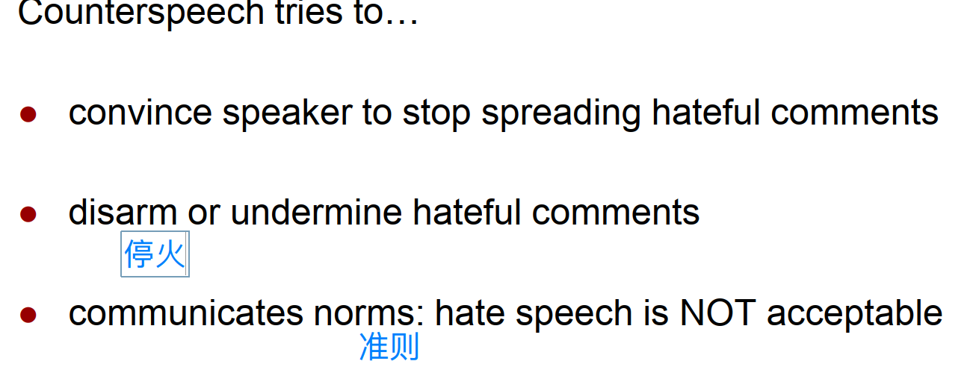

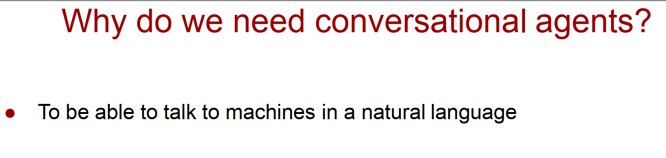

﻿Part 4: Privacy and Security

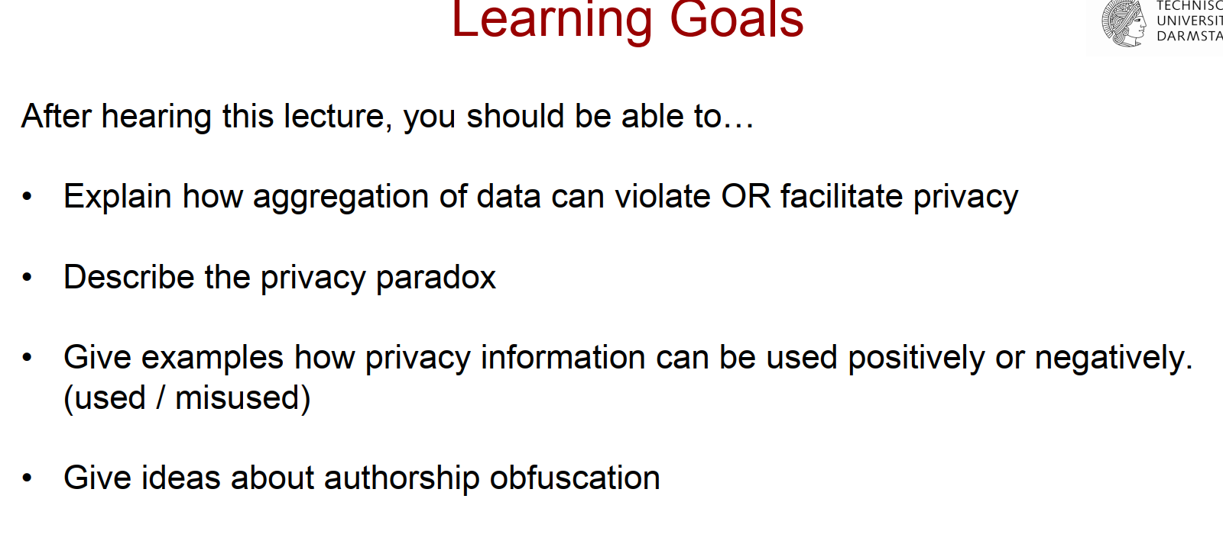

● Algorithms for demographic inference and personality profiling

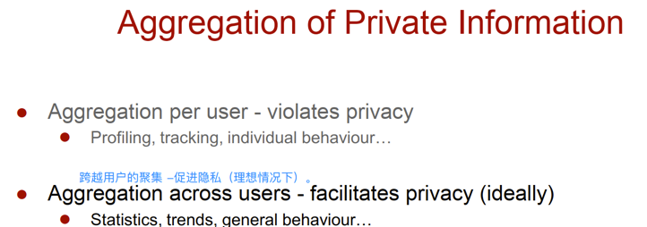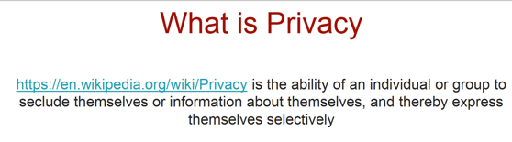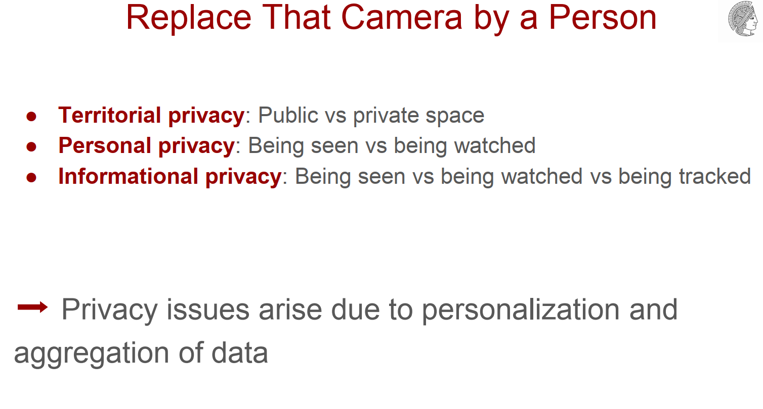



**Privacy Paradox: Highly concerned about the users’privacy but easily trade their personal data.**

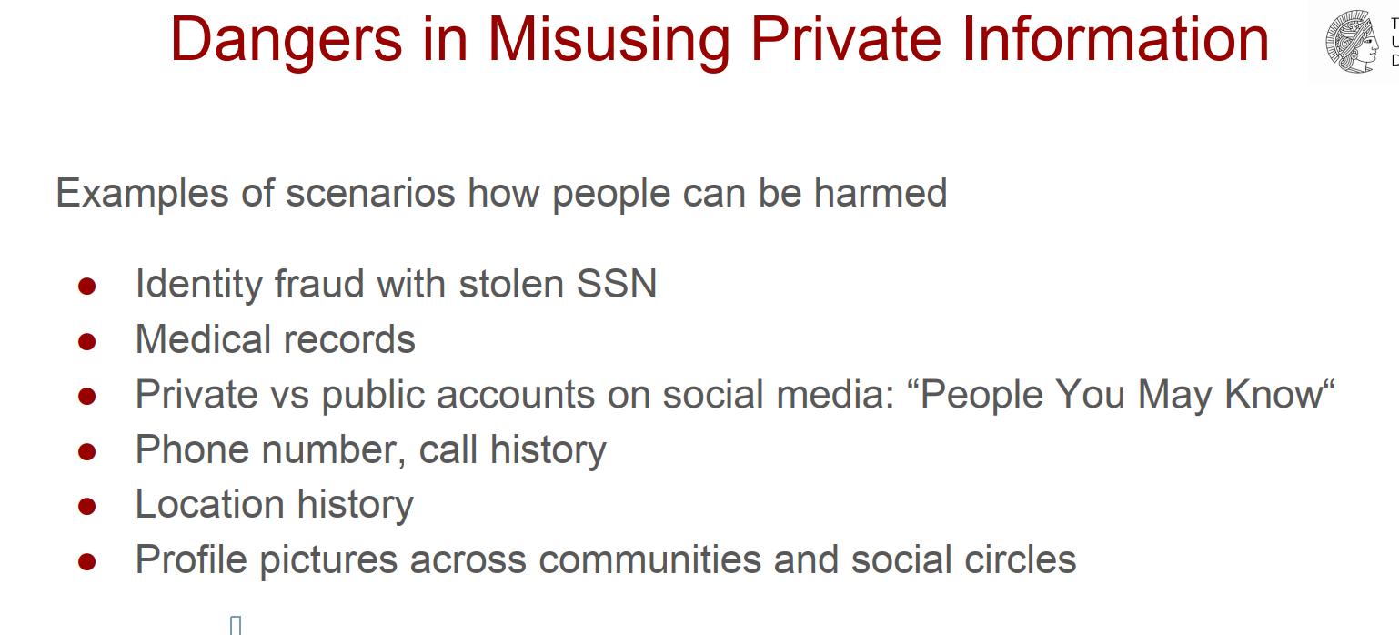

**﻿Personally identifiable information (PII) ﻿or sensitive personal information (SPI)**

**Collection of PII is not illegal. And without security there is no privacy.**

**﻿Demographic Profiling:**

**﻿ Private traits and attributes are predictable from digital records of human behavior.**

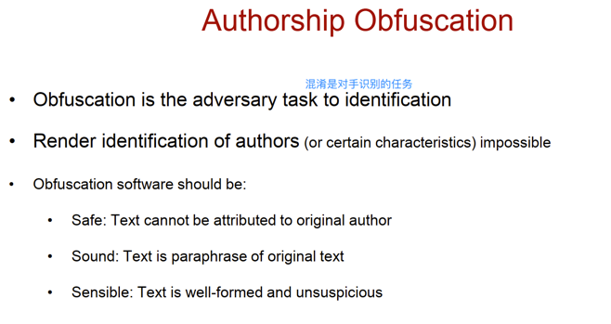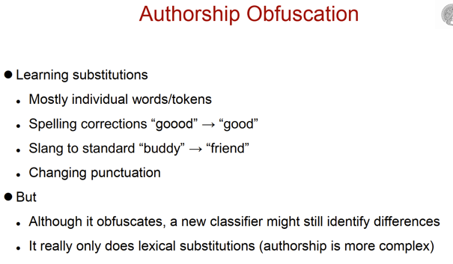

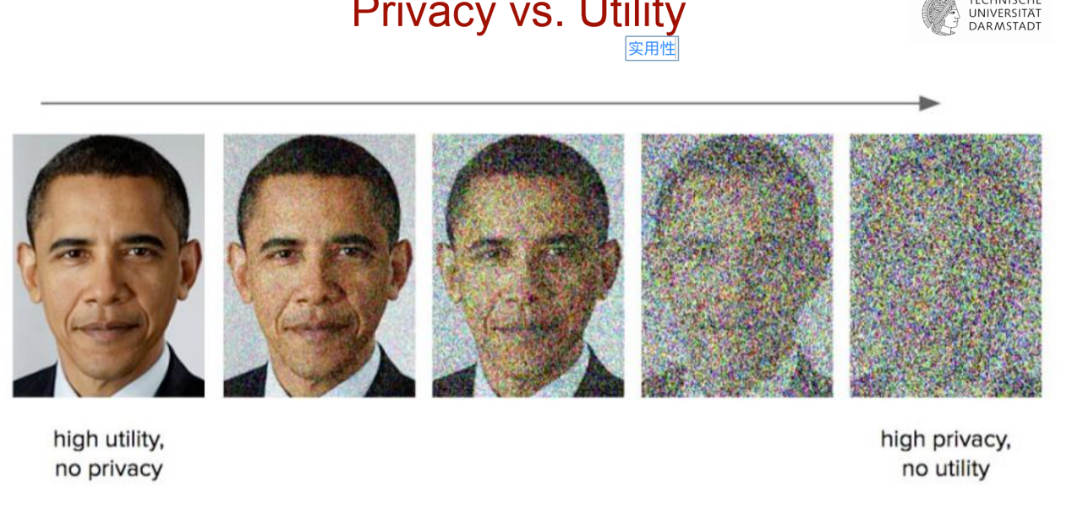

● Anonymization of demographic and personal traits

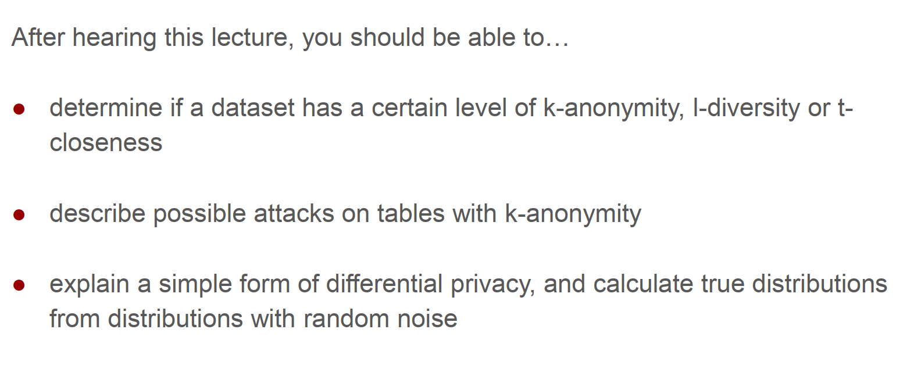

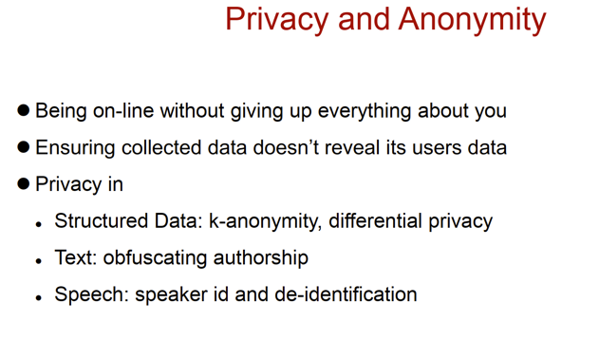

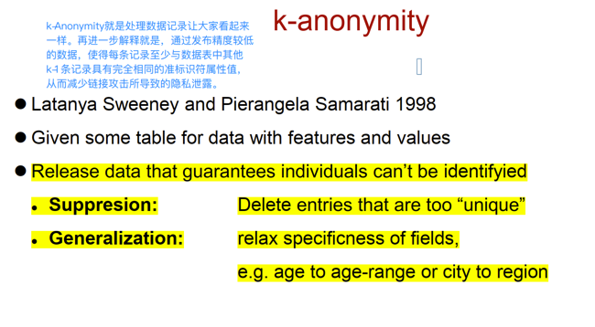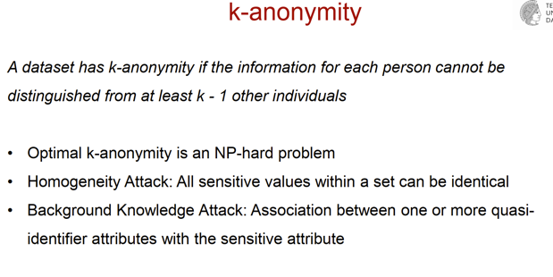

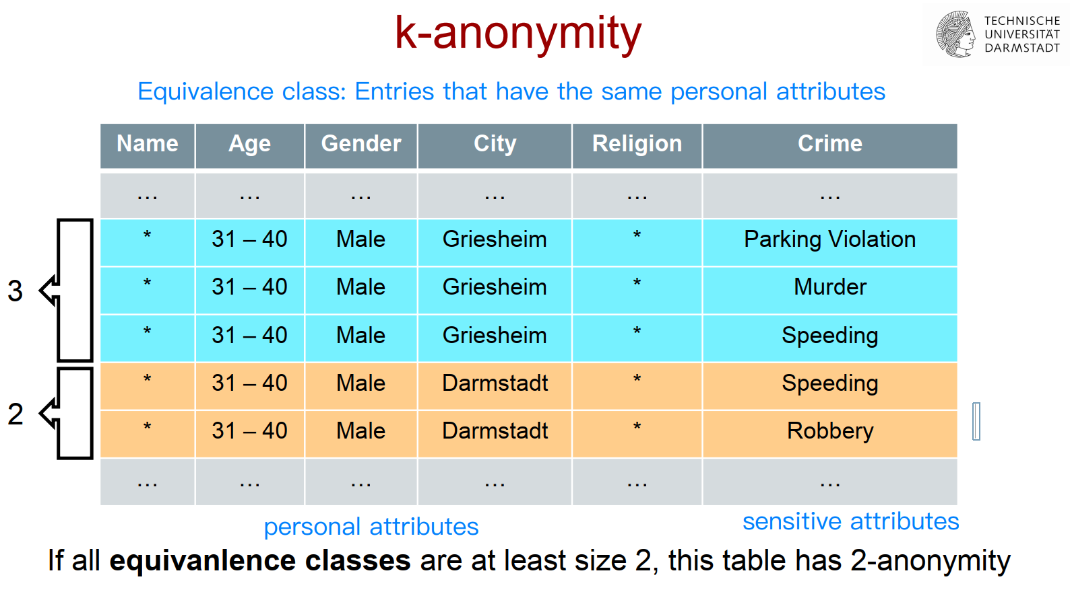

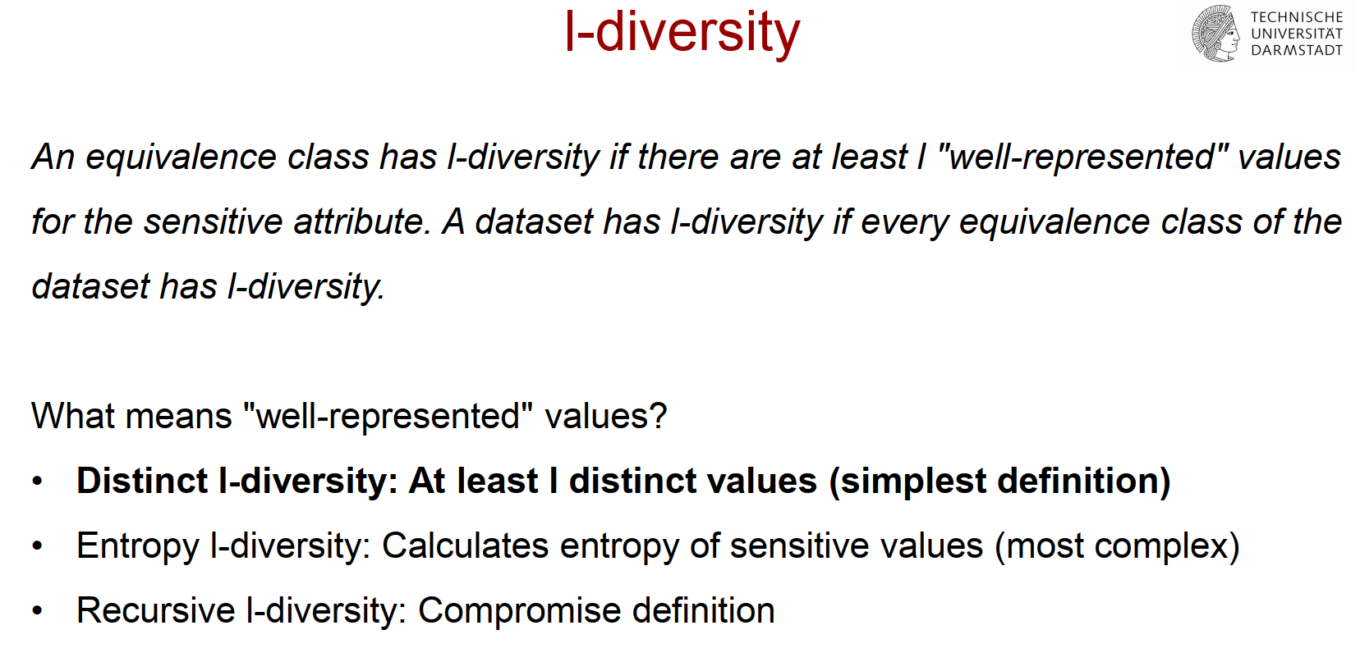

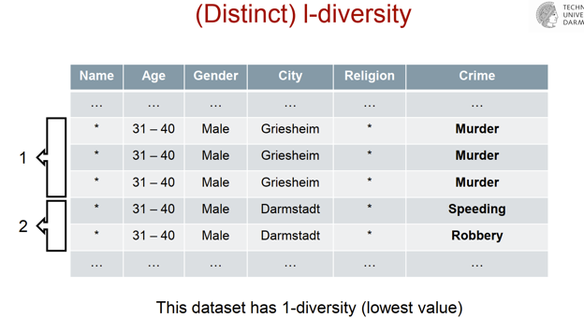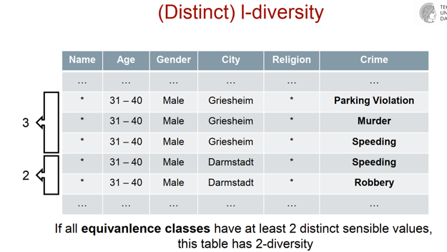

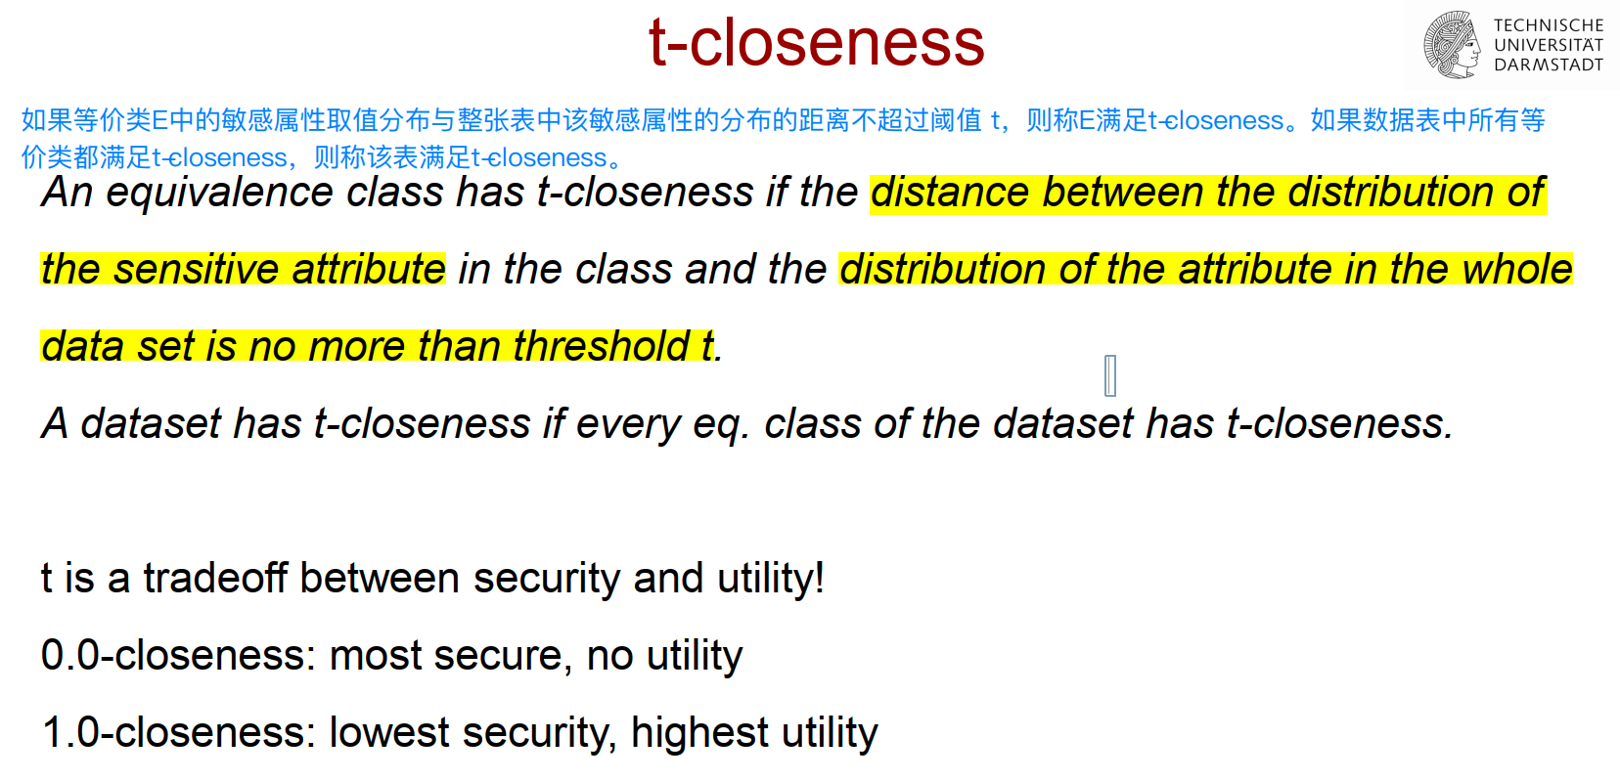

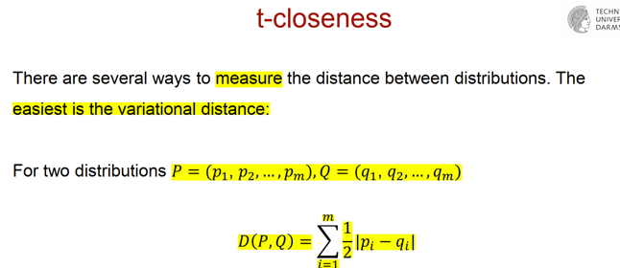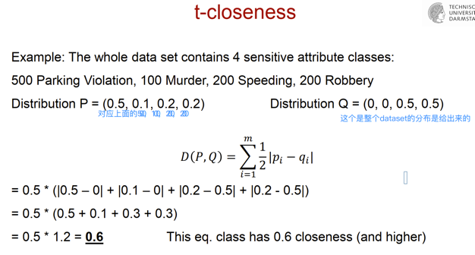

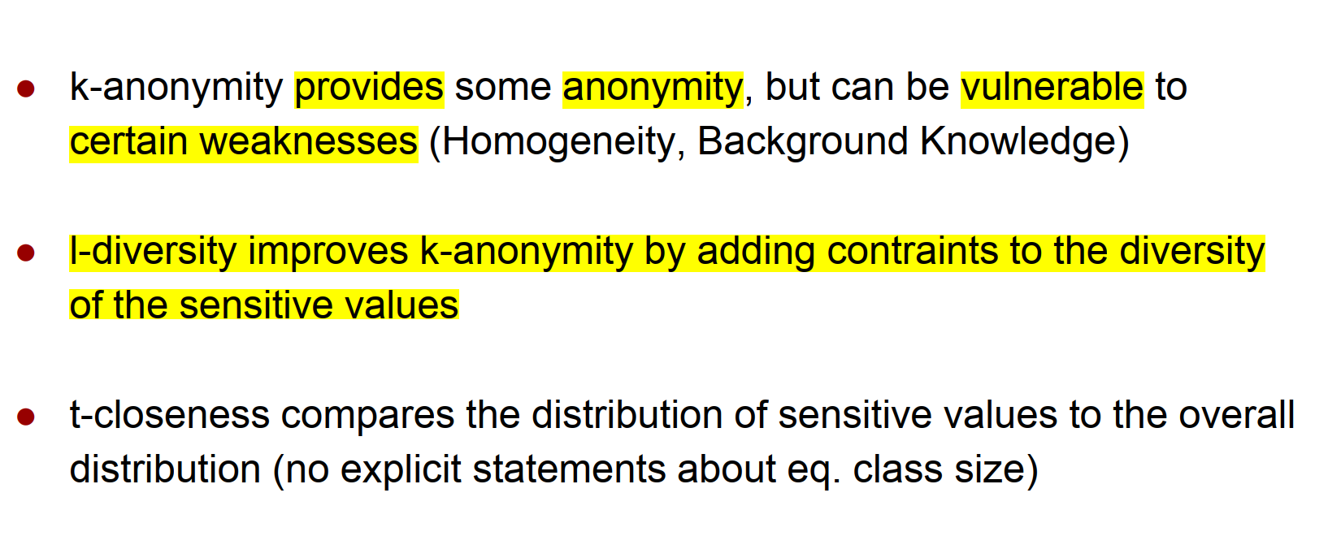

**﻿Differential Privacy：﻿Basic idea: Introduce randomness**

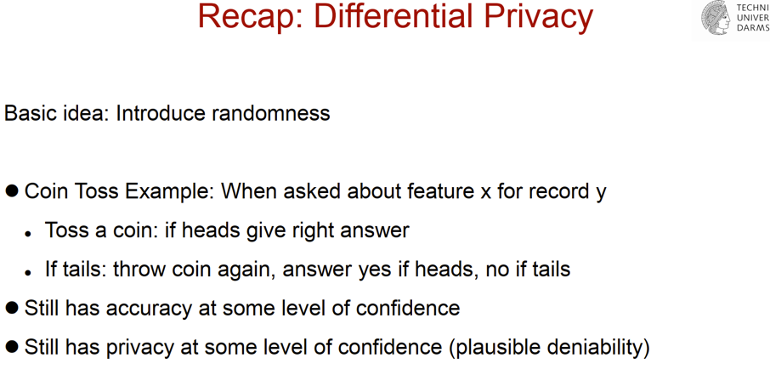

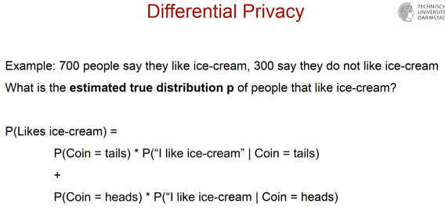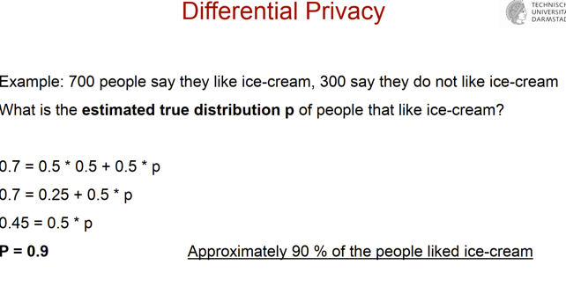

﻿Part 5: Democracy and the language of manipulation

● Approaches to identify propaganda and manipulation in news

● Fake news

● Political and media framing

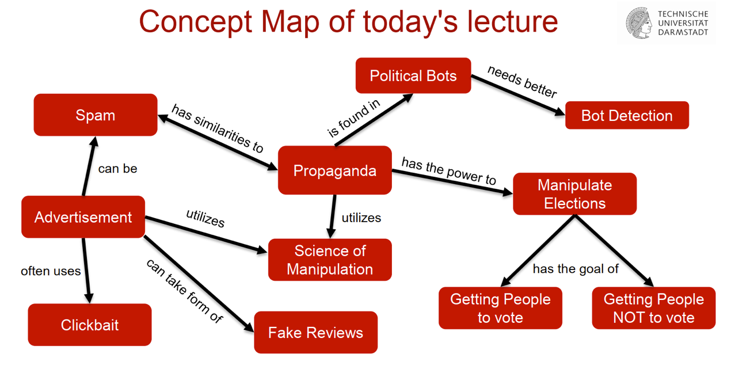

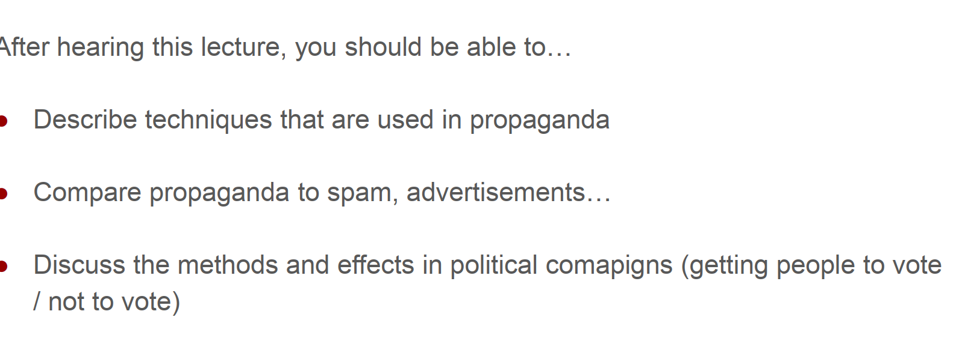

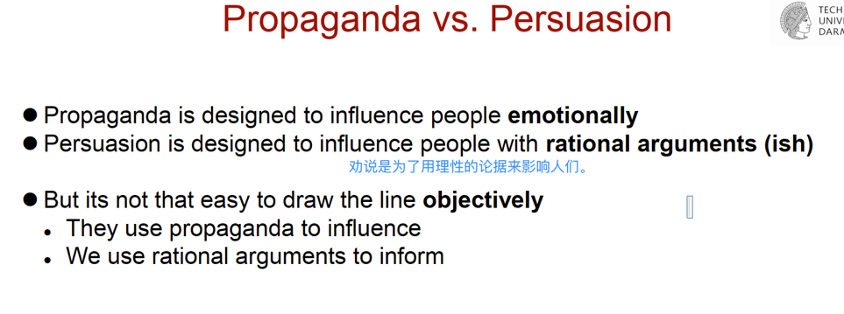

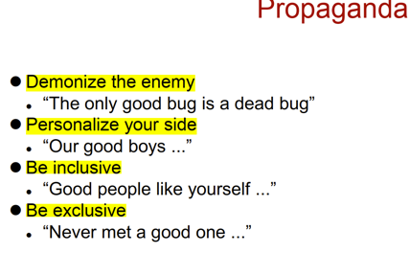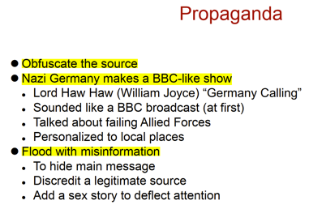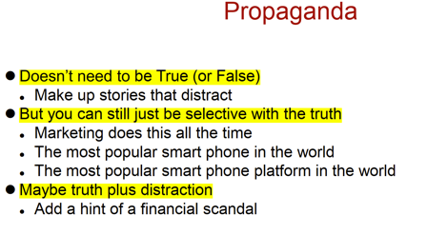

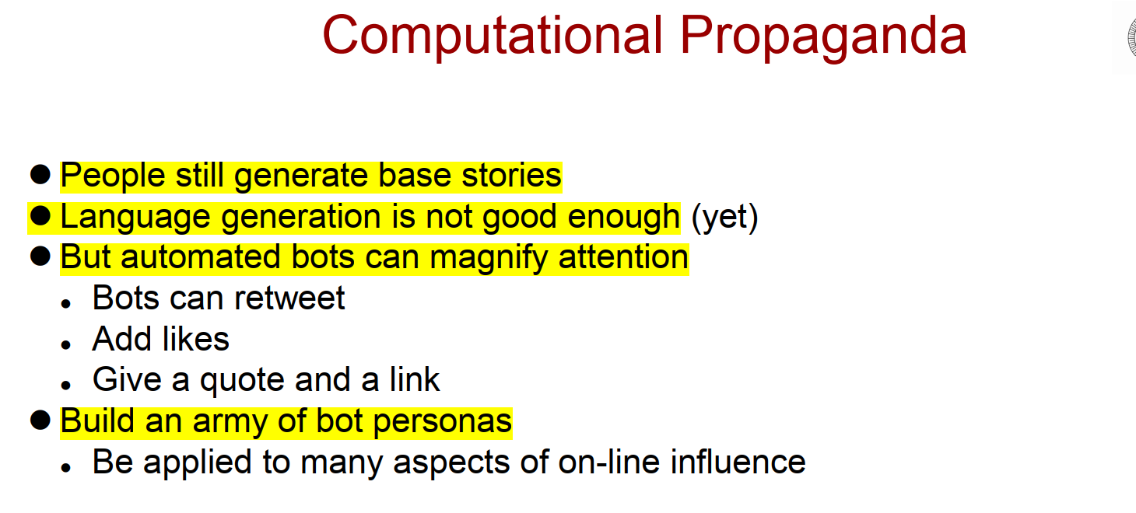

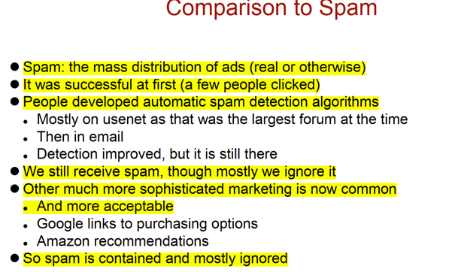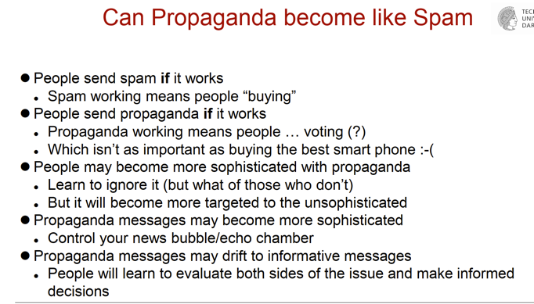

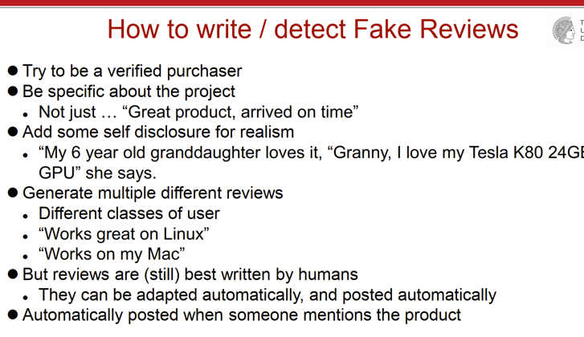

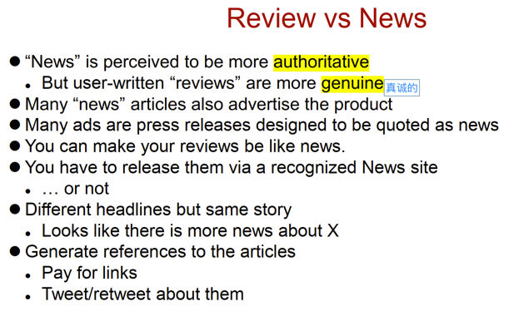

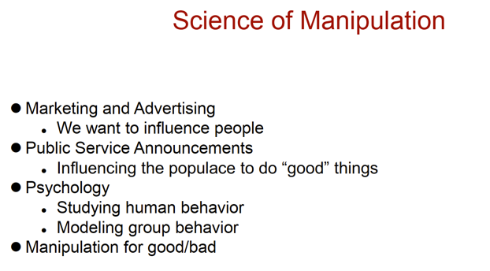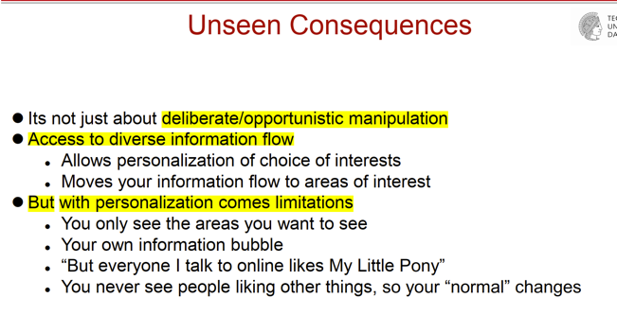

﻿Part 6: NLP for Social Good

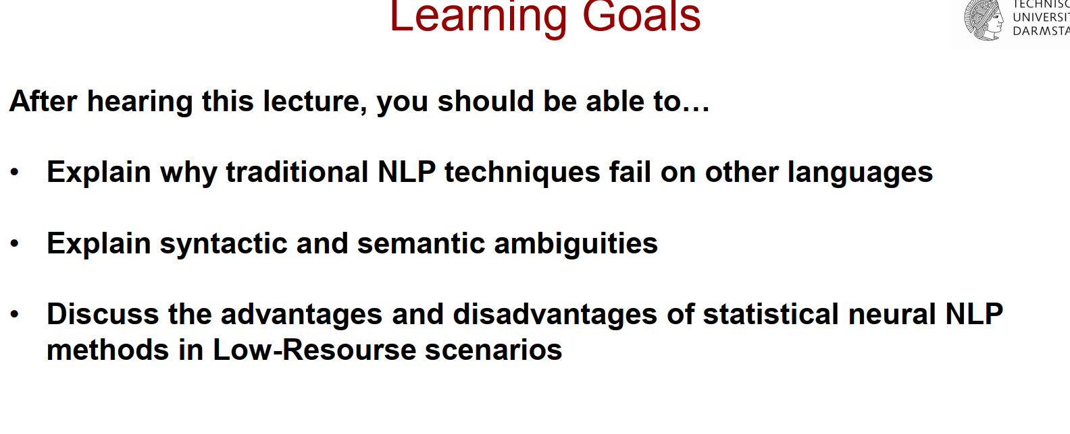

● Low-resource NLP, applications for disaster response and monitoring diseases

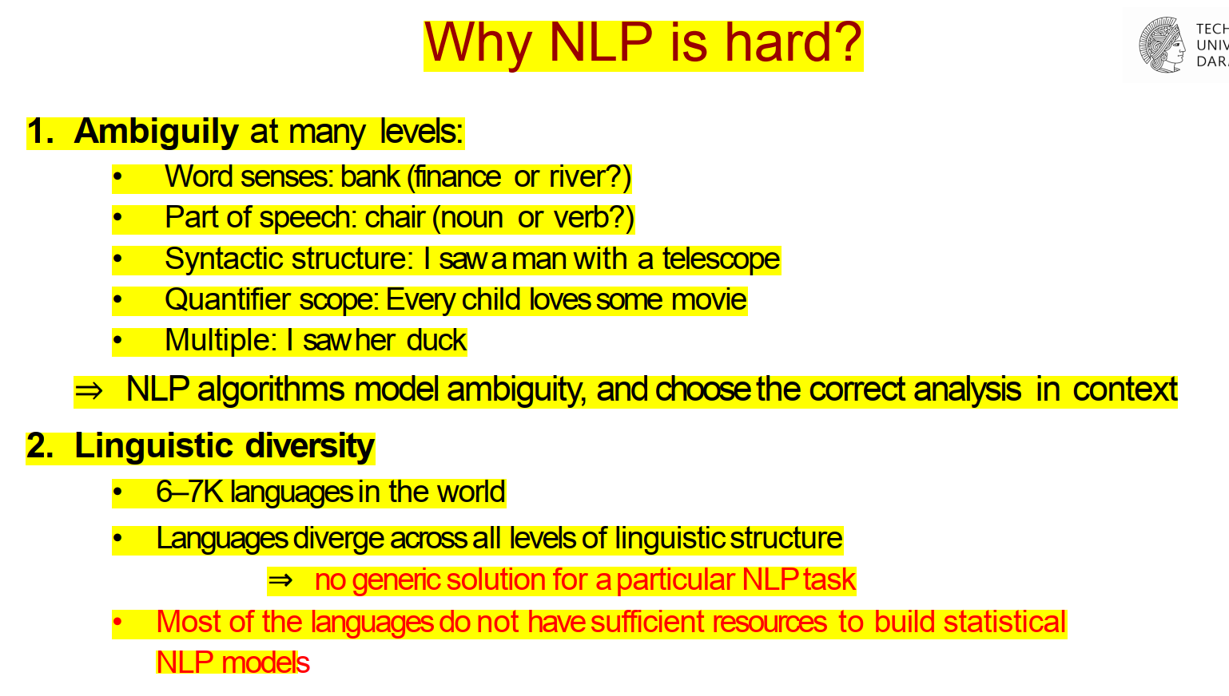

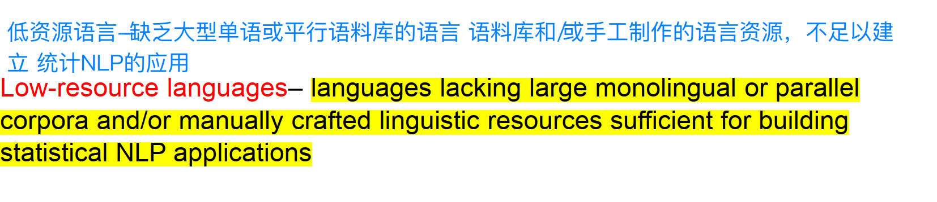

**Resource-rich？**

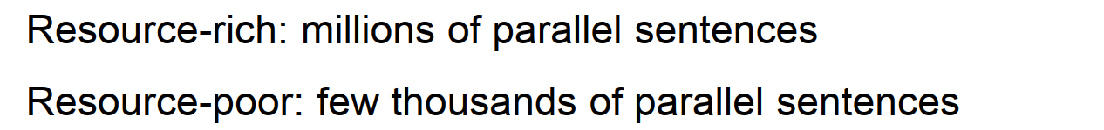

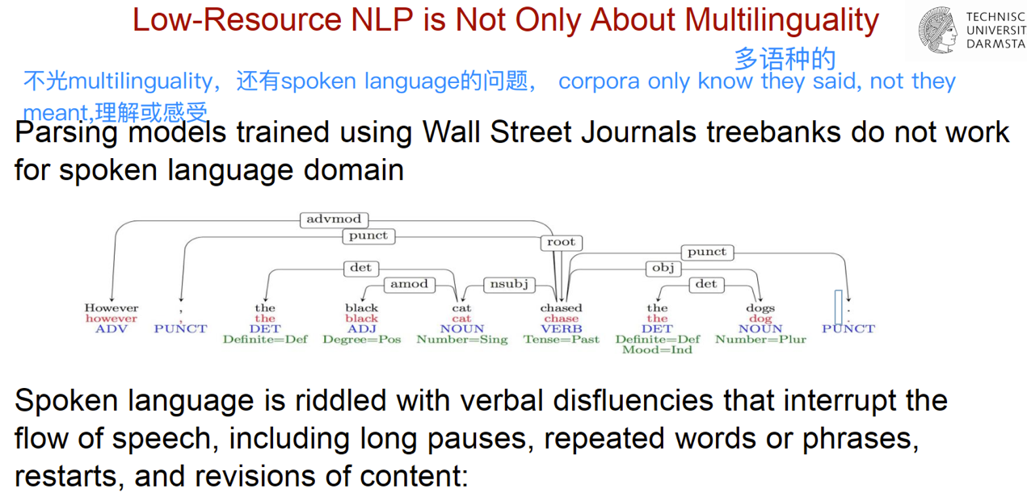

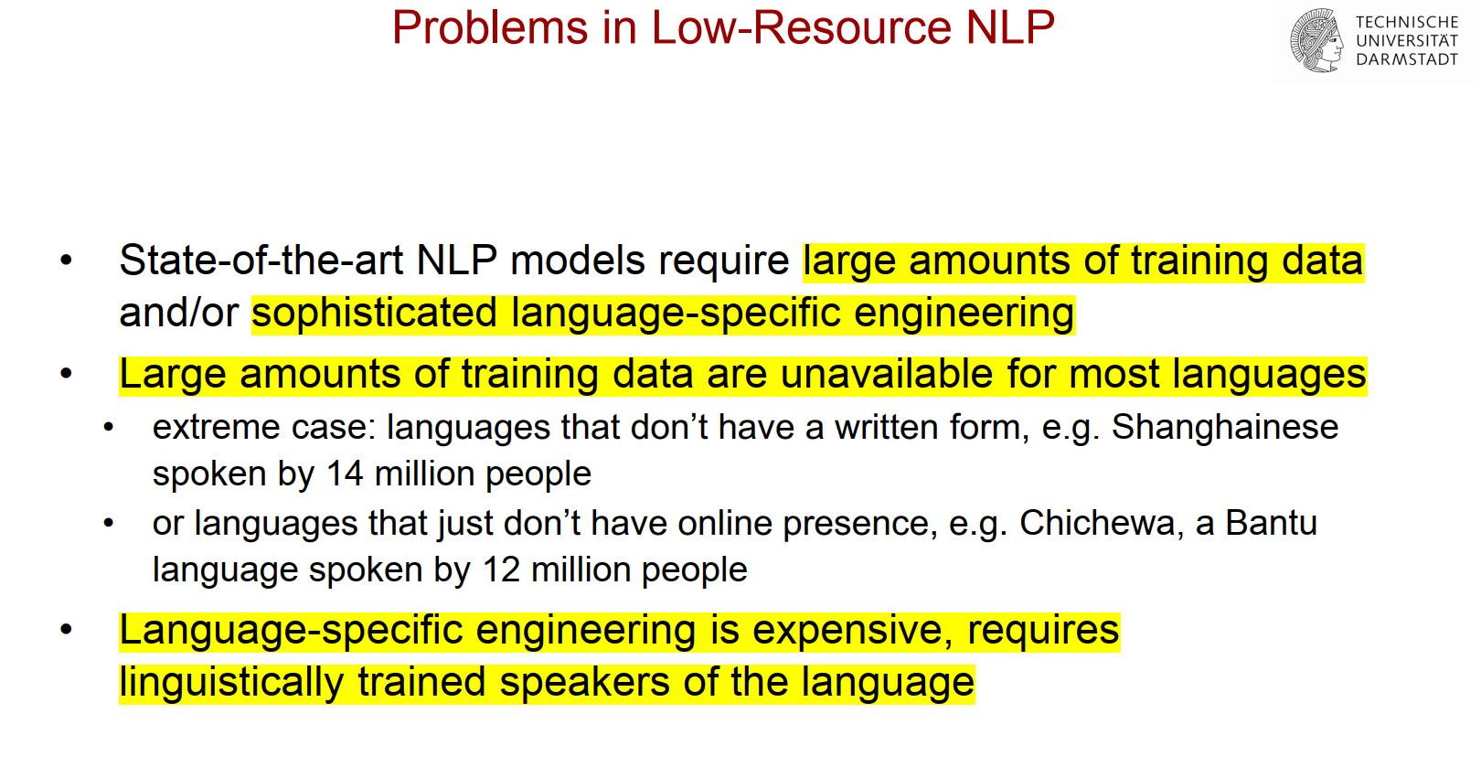

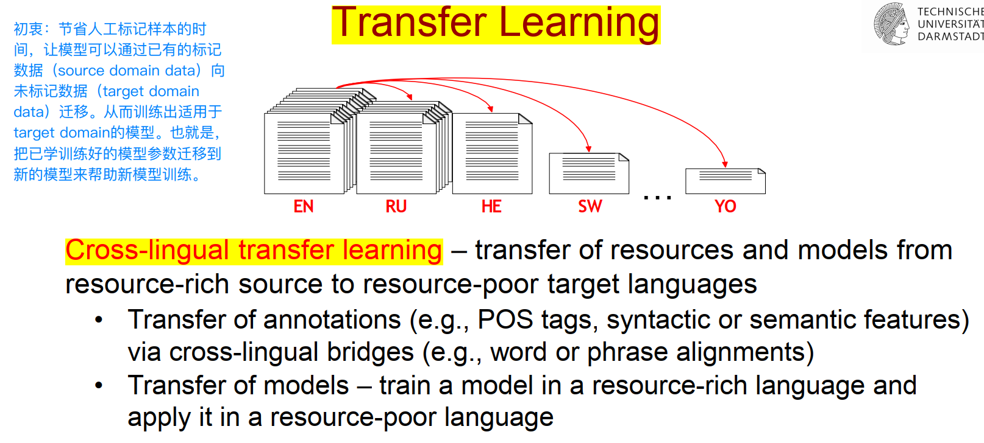

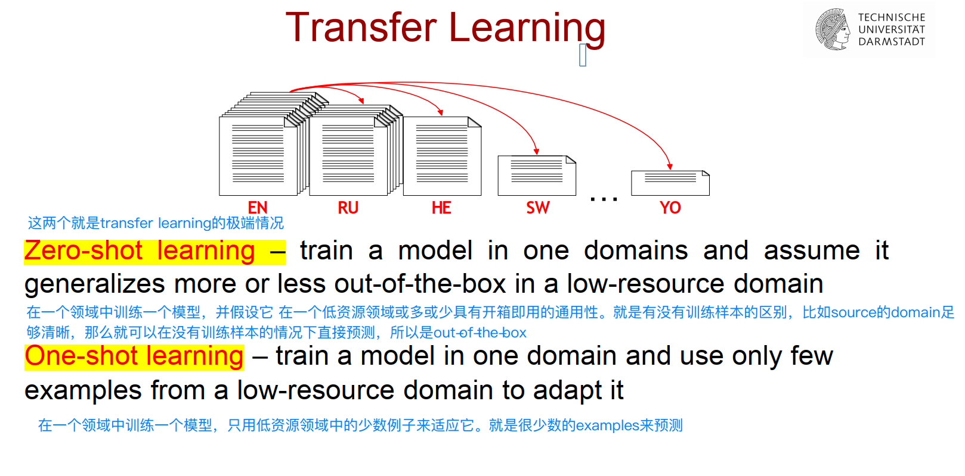

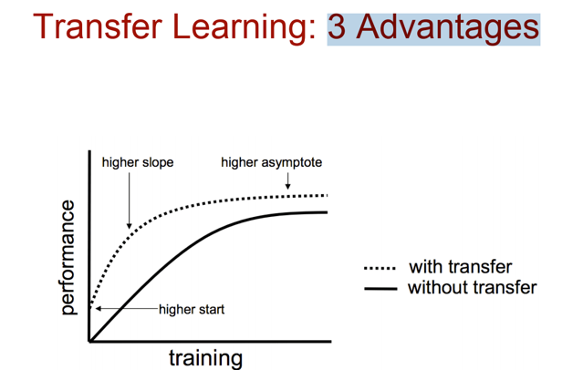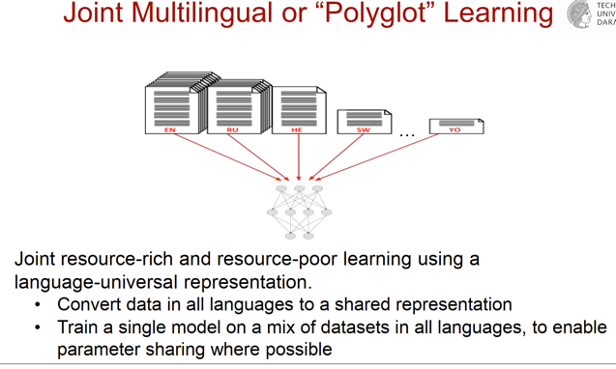

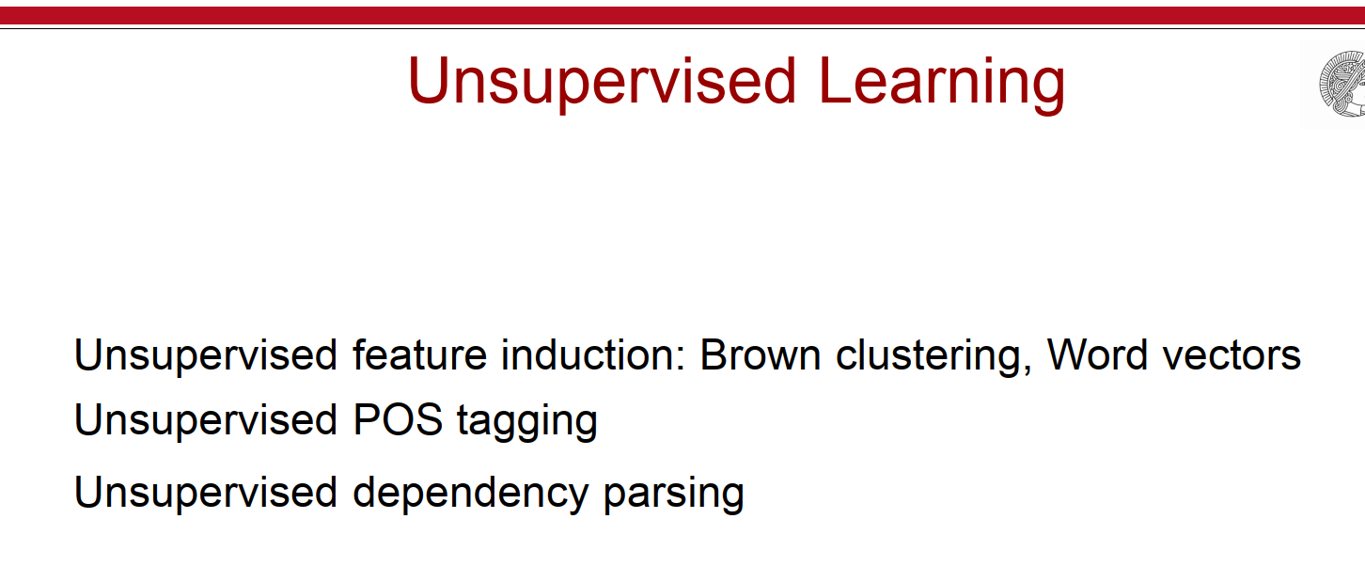

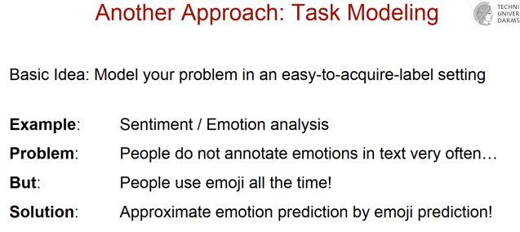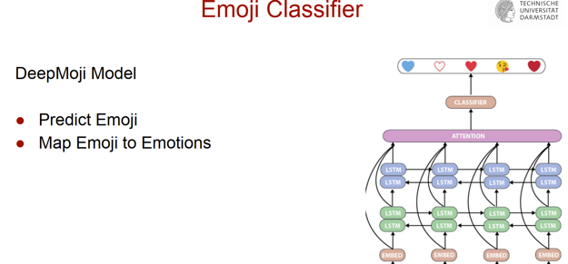

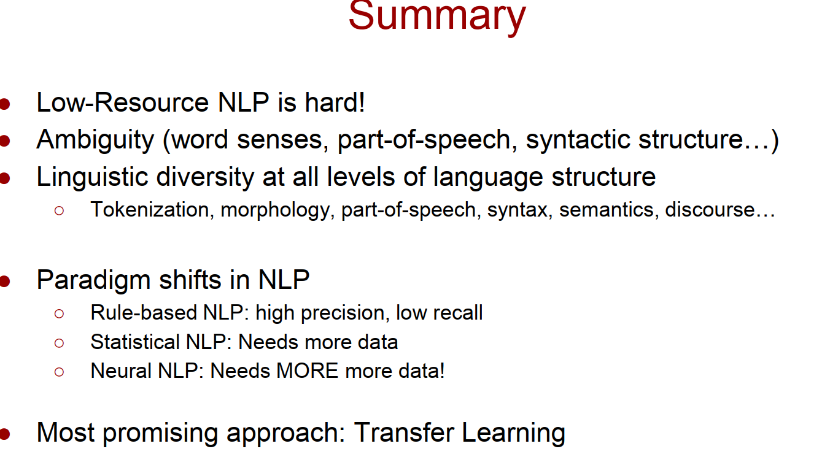

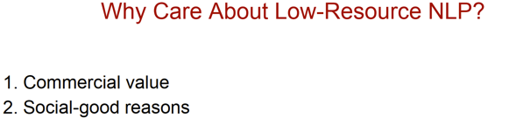for社会原因： identify outbreak of disaster, or 地震之类的紧急事件emergency response。

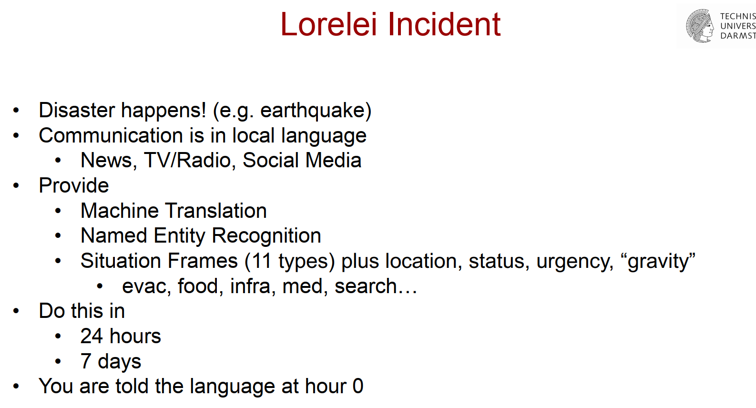

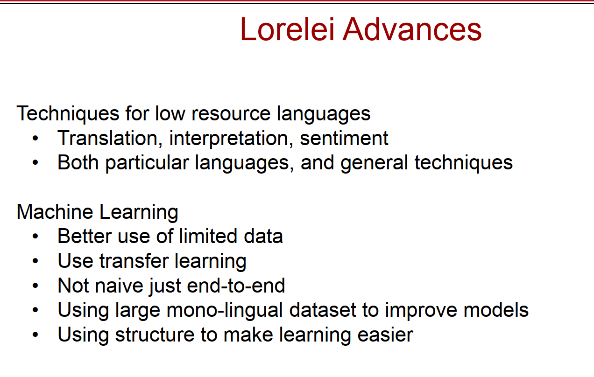

● Medical applications, psychological counseling

● Interfaces for accessibility.

HW:

**Question 1: How the performance changes accross language families and available dataset size? Make a conclusion of how the model's prediction depends on the available data. (2 point)**

According to the received results we can see that the high-resource languages show better performance than the low-resource. Mainly, the dataset size and available training data have an impact on the computational results. The more data is available for the language the better the model predicts the labels.

**Question 2: What role does the training set size plays for the model? Which problem regarding training sets occurs when you deal with the low-resource languages? (2 points)**

Training set size determines how good the model will be trained. Unfortunately, the amount of available data for the low-resource languages is lower than for the high-resource. Therefore, it is difficult to train the model so that it can provide a good prediction for the given input sequense.

**Question 3: What do the parameters "n_layers", "bidirectional" and "dropout" (variable "params" in the first code cell) of the LSTM model mean? According to your research results please answer the following questions regarding the low-resource languages: (4 points)**

**- What happens when you increase the variable n_layers and why?**

**- What changes when the model is unidirectional and why?**

**- What happens when you increase the dropout and why?**

n_layers: This parameter determines how many LSTM networks are used and connected together so that one LSTM takes the output of another one as an input. Combining more LSTM networks may lead to the greather results but they need a lot of high-quality training data as well. Usually 2 networks are enough to deal with the complex labels. Since it isn't enough available training data for the low-resource languages, increasing the number of the LSTM networks should lead to poorer results.

bidirectional: Using bidirectional or unidirectional model. Bidirectional LSTM model, as the name says, has two directions, in which they can extract information from the input sequence: forward and backward. By this way it can store the results in his hidden states to look up into it at the any time for generating the output. Combining the forward and backward directions usually produceses better results. Unidirectional model has only one forward direction, thus the predicition of labels contains more errors. Applying an unidirectional LSTM model to train on the data for the low-resource language leads to poorer results.

dropout: Dropout determines the probability of dropout for each single node in the LSTM network. That means the output from the node will be completely ignored for the next round. This concept is important to prevent overfitting so that the features learned in the first rounds don't have a significant impact on the next rounds, i.e. later learned features can be easilly stored in the model's memory. Increasing the dropout for the low-resource languages means ignoring more features when training. This leads to poorer results.

**Question 4: Define the term "label noise". After that, please answer what happens if the labels in the training data are noisy? (2 points)**

Sometimes we don't have any access to the high-quality labeled training data. In this case, to train the model, we need to deal with so called noisy labeled data, i.e. data that contains errors. Applying such data as the training dataset for the model will cause significant errors by predicting the labels.

问题1：性能在不同的语言系列和可用的数据集大小之间如何变化？对该模型的预测如何取决于可用的数据作出结论。(2分)

根据收到的结果，我们可以看到，高资源语言比低资源语言表现得更好。主要是数据集大小和可用的训练数据对计算结果有影响。语言的可用数据越多，模型预测的标签就越好。

问题2：训练集的大小对模型起什么作用？当你处理低资源语言时，哪个关于训练集的问题会出现？(2分)

训练集的大小决定了模型的训练效果如何。不幸的是，低资源语言的可用数据量比高资源语言的低。因此，很难对模型进行训练，使其能够为给定的输入序列提供一个良好的预测。

问题3：LSTM模型的参数 "n_layers"、"bidirectional "和 "dropout"（第一个代码单元的变量 "params"）是什么意思？根据你的研究结果，请回答以下关于低资源语言的问题：（4分）

- 当你增加变量n_layers时会发生什么，为什么？

- 当模型是单向的，会有什么变化，为什么？

- 当你增加辍学率时会发生什么，为什么？

n_layers。这个参数决定了有多少个LSTM网络被使用并连接在一起，以便一个LSTM把另一个的输出作为输入。结合更多的LSTM网络可能会导致更好的结果，但它们也需要大量高质量的训练数据。通常，2个网络就足以处理复杂的标签了。由于低资源语言没有足够的可用训练数据，增加LSTM网络的数量会导致较差的结果。

双向的。使用双向或单向的模型。双向LSTM模型，顾名思义，有两个方向，它们可以从输入序列中提取信息：向前和向后。通过这种方式，它可以将结果存储在他的隐藏状态中，以便在任何时候都能查询到，从而产生输出。将前向和后向结合起来通常会产生更好的结果。单向模型只有一个前进方向，因此标签的预测包含更多的错误。应用单向LSTM模型对低资源语言的数据进行训练会导致较差的结果。

辍学。辍学决定了LSTM网络中每个单一节点的辍学概率。这意味着该节点的输出将在下一轮中被完全忽略。这个概念对于防止过度拟合很重要，这样在第一轮学到的特征就不会对下一轮产生重大影响，也就是说，后来学到的特征可以很容易地存储在模型的内存中。增加低资源语言的辍学率意味着在训练时忽略了更多的特征。这就导致了较差的结果。

问题4：定义 "标签噪音 "一词。之后，请回答如果训练数据中的标签有噪音会怎样？ (2分)

有时我们无法获得高质量的标签训练数据。在这种情况下，为了训练模型，我们需要处理所谓的噪声标签数据，即含有错误的数据。应用这样的数据作为模型的训练数据集，会导致预测标签的重大错误。

